One Common Framework for Information and Communication Systems in Transport and Logistics

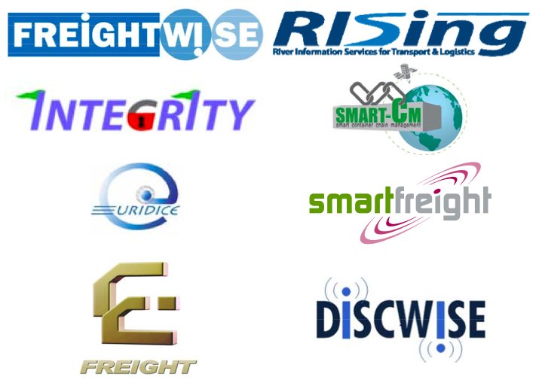

Revision/Document History

|  |  |  |  |
| --- | --- | --- | --- |
| **Index** | **Date** | **Authors** | **Subject** |
| 0 | 05.07.2010 | Jan Tore Pedersen (Marlo), Paolo Paganelli (Insiel), Frank Knoors (Logit Systems) | Initial draft version |
| 1 | 27.09.2010 | Jan Tore Pedersen (Marlo), Paolo Paganelli (Insiel), Frank Knoors (Logit Systems) plus contributions from others | Second draft version |
| 2 | 18.10.2010 | Jan Tore Pedersen (Marlo), Paolo Paganelli (Insiel), Frank Knoors (Logit Systems), Nils Meyer-Larsen (ISL) plus contributions from others | Final version |
| 2.1 | 12.12.2010 | Frank Knoors (Logit Systems), Paul Davidsson (BTH) for section 10.1 | After DiSCwise Advisory Board 17.11.2010:  1) Demonstrating the use of the framework by specific actors: Section 8 (new), Section 9.1 (extended), Section 9.2 (new), Section 9.3 (extended), Section 9.4 (revised);  2) Fit the framework into a larger set of toolboxes for interoperability: Section 10.1 (new);  3) Address how we can break through the vested interests of ‘large system’ suppliers: Section 10.2 (new); |
| 2.2 | 18.4.2011 | Frank Knoors (Logit Systems) | After additional input received from the DiSCwise Advisory Board. |
| 2.3 | 25.4.2011 | Frank Knoors (Logit Systems) | Added references to detailed Common Framework message definitions.  Introduced Common Regulatory Schema (CRS), in line with e-Freight developments.  Aligned terminology with pilot design document. |
| 2.4 | 5.5.2011 | Frank Knoors (Logit Systems) | Added mapping between Common Framework and GS1 ILIM, OASIS UBL. |

**Summary**

Supply chains are becoming more and more global and responsive. The drive for more environment-friendly, decongested and secure logistics has led to the introduction of such concepts as Co-Modality, Motorways of the Sea, Secure Trade Lanes and Green Corridors. Effective logistics and supply chain management requires sharing knowledge and information along the supply chain. In this context, efficient cooperation between actors in integrated supply chains becomes more and more important. To achieve this, the information and communication systems used for managing transport and logistics operation need to interact efficiently, share information – they must be interoperable – and the actors must be enabled to share that information according to their own business rules. Similar exchange of information is necessary between private stakeholders and authorities.

Despite the fact that standards exist, industry representatives have realised that a paradigm shift in interoperability is needed if logistics efficiency is to be improved and political goals of reducing the environmental impact of transport are to be met. One example of an industrial initiative in this direction is the development of a new Logistics Interoperability Model (LIM) by GS1. Behind the LIM proposal are large manufacturers and logistics services providers (LSPs).

A number of EU funded research and development projects have been addressing the issues of information and communication technologies in transport and logistics. While industry led initiatives often started from large companies, EU funded projects have also included SMEs as users of interoperability standards. The DiSCwise project was launched in order to specifically address this issue even stronger, also demonstrating the use of ICT solutions in practice that would support SMEs to use such standards.

Traditionally, these projects have been quite autonomous and there has been little coordinated contact between the projects. This has, however, now changed. The partners in a number of ongoing projects have realised that there are project benefits that may be exploited from better cooperation. This view is also shared by the EU Commission. Therefore DiSCwise also engaged to strengthen concertation between these projects. The specific added value of DiSCwise in this concertation was the focus on SMEs and the validation of the interoperability framework by industrial pilots in which SMEs were a key participate. Part of that validation was also the interconnection with the Descartes Global Logistics Network (GLN), showing how interoperability can be ensured to a large logistics platform that connects a multitude of logistics actors, each with their own ICT systems.

As industrial developments and the research community have reached similar conclusions, a joint initiative has been taken to improve interoperability considerably by developing one Common Framework for exchange of information between ICT systems in transport and logistics. Although this initiative was started by several individual EU projects and their project officers, it is now starting to be adopted in a more orchestrated way by the EU Commission.

The Common Framework supports interoperability between commercial actors and communication to authorities and transportation network responsible – to make the best possible use of the available transportation infrastructure, provide appropriate supply chain security, and support compliance requirements. To drive the required paradigm shift, the Common Framework addresses interoperability issues at two main levels in a technology-independent way. At the process and information level, the Common Framework is developed to ensure that only necessary and sufficient information is being exchanged, that the number of messages and their complexity is kept to a minimum, that the messages are unambiguous and that there will essentially be no need for business process harmonisation. At the architectural level, the framework builds on open services platforms and self-configuring logistics networks and devices - to support Intelligent Cargo, Single Windows and other mechanisms for collaboration and monitoring.

The Common Framework approach lowers the cost for companies to electronically connect in transport and logistics, without forcing those who already have invested much in the area to stop using what they have. Close cooperation has been established with standards organisations. In addition to being deployed in industry, the Common Framework will provide a mechanism for current and new research and development project to provide interoperability of relevant results.

Contents

1 About this Document 9

1.1 Background 9

1.2 Follow-Up 9

2 Rationale 10

2.1 Industrial and Political Initiatives 10

2.2 Recent EU Project Results 11

2.3 Going Forward 12

3 Scope 13

3.1 Transport and Trade 13

3.2 Roles 13

3.2.1 What is a role 13

3.2.2 View from Industry 14

3.2.3 Roles from the FREIGHTWISE Framework 14

3.2.4 Conclusion 15

3.3 Business Processes 16

4 Interoperability 18

5 ICT Systems Involved 19

5.1 Overview 19

5.2 Governance 21

5.3 Interactions 21

6 The Common Framework 22

6.1 Introduction 22

6.2 Framework Requirements 22

6.3 Scope 23

6.4 Domains 27

6.4.1 Cooperative Systems 27

6.4.2 Transport Demand 28

6.4.3 Transport Supply 28

6.4.4 Transport Chain Security and Compliance 28

6.4.5 Intelligent Cargo 28

6.5 Interactions between Domains 29

6.5.1 Interaction between Transport Demand and Transport Supply 29

6.5.2 Communication between Logistics Services Provider and Transport Regulator 31

6.5.3 Communication between Logistics Services Provider and Transportation Network Manager 33

6.6 Intelligent Cargo 34

6.7 Mapping between the Common Framework and other standards 38

6.7.1 Common Framework mapped to GS1 LIM 38

6.7.2 Common Framework mapped to OASIS UBL 39

7 Common Framework Summary 41

8 Usage of the framework 42

9 Scenario 43

9.1 Scope 43

9.2 Description of Integrated Scenario 45

9.2.1 Sea/hinterland interfaces 45

9.2.2 Secure Trade Lanes 47

9.2.3 Co-modality in Logistics Planning and Execution 49

9.3 Integrated Process Description 50

9.4 Fit Between the Integrated Scenario and the Common Framework 52

9.5 Interoperability of Systems 53

9.5.1 Use of systems and standards from previous projects 53

9.5.2 Connectors 54

9.5.3 Intelligent Cargo 55

10 Using the Common Framework to implement end-to-end services 57

10.1 Simplifying the use of end-to-end transport options 57

10.2 Simplifying the connection to proprietary systems 59

11 Proposed Actions 60

11.1 Introduction 60

11.2 Linking Systems Developed in EU Projects 60

11.3 GS1 Cooperation 60

11.4 CEN and UN/CEFACT Cooperation 60

11.5 Harmonisation with the WCO Data Model 60

11.6 Complementing PEPPOL 61

11.7 Extra Dissemination 61

11.8 Electronic Waybill 61

12 Appendix 1: Relevant EU Projects 62

12.1 FREIGHTWISE 62

12.2 e-Freight 62

12.3 INTEGRITY 62

12.4 Smart-CM 62

12.5 SMARTFREIGHT 63

12.6 EURIDICE 63

12.7 RISING 63

12.8 DiSCwise 63

12.9 EasyWay 64

12.10 SuperGreen 64

12.11 BeLogic 64

13 Appendix 2: Results form INTEGRITY and Smart_CM 65

13.1 INTEGRITY 65

13.1.1 INTEGRITY – Intermodal Global Door-to-door Container Supply Chain Visibility 65

13.1.2 SICIS – An open IT platform providing Supply Chain Visibility 65

13.2 Smart_CM 67

14 Appendix 3: Standardisation 70

14.1 Introduction 70

14.2 GS1 70

14.3 UBL/OASIS 70

14.4 CEN 70

14.5 UN/CEFACT 70

15 Appendix 4: Terms of Reference 71

16 Appendix 5: EU Policies 73

17 Appendix 6: Surrounding Activities 76

17.1 GS1 76

17.2 PEPPOL 76

17.3 Mode Based Initiatives 76

17.3.1 ITS 76

17.3.2 RIS 77

17.3.3 TAF/TSI 77

17.3.4 The EU e-Maritime initiative 77

17.3.5 IATA 77

18 Appendix 7: Europe 2020 and the Revision of the White Paper for Transport 78

# About this Document

## Background

After a process involving the issuing of a document outline in May 2010 and a draft report in the beginning of July 2010 with comments from the EU Commission after these, this document completes the process and documents One Common Framework for Information and Communication Systems in Transport and Logistics as it is perceived in September 2010.

Contribution to this report has been given by representatives from the following list of EU projects (a short description of these projects is provided in Section 12):

* FREIGHTWISE
* e-Freight
* INTEGRITY
* Smart-CM
* SMARTFREIGHT
* EURIDICE
* RISING
* DiSCwise

These projects have been addressing the issues of information and communication technologies in transport and logistics. Each of these projects focussed on specific issues that needed detailed analysis. DiSCwise in particular focussed on SMEs and how they could join into a fully digital supply chain. Now the partners in the projects listed above have realised that there are benefits that may be exploited from better cooperation and the exploitation of One Common Framework for Information and Communication Systems in Transport and Logistics.

Partners in the projects also acknowledge that such cooperation will also provide benefits for the transport industry (shippers, terminal operators, carriers, logistic service providers (LSPs) operating at European and global level), provided that this Common Framework is widely accepted and employed by the operational transport and logistics community (those who need transport and those who perform it). In this case, there will be benefits for companies developing and maintaining ICT solutions in supply chain management and monitoring.

## Follow-Up

This report will be accompanied by two more results.

* Examples showing how the systems developed in the above mentioned EU projects could be used in supply chains in an integrated setting. At least one such example has been presented in the ECITL in Bremen in November 2010. A more extensive example was called for in the call for proposals ‘GC.SST.2011.7-11. E-freight solutions and supply chain management’ that closed end of 2010 and may see a dedicated project to be launched during 2011.
* A document that will analyse the economic impact of the use of One Common Framework for Information and Communication Systems in Transport and Logistics. This document will be concluded in 2011.

# Rationale

## Industrial and Political Initiatives

The projects listed in Section 1 represent a long line of development projects funded by various DGs[1] in the EU Commission in the area of freight transport management and related security issues. Most of these projects have been loyal to the standardisation schemes offered by organisations like CEN and UN/CEFACT in the important area of information exchange in transport and logistics. In other words, electronic documents standardised by these organisations were implemented in these projects.

Standardisation organisations describe their electronic documents through specifications and implementation guidelines. This leads to situations where organisations and groups of industries are interpreting specifications differently and the result is lack of interoperability.

This is not just a conceptual problem discussed in research and development projects, put problems experienced by industry to the extent that GS1 (see Section 14.2) established its Logistics Forum with representatives from companies like Unilever, DHL, Schenker, Firmenich, Army & Air Force Exchange Service, GEFCO, Bring Frigoscandia, DSV, ICA, DIA (Carrefour), El Corte Inglés, Mercadona, Eroski, Easytech, Campofrío, and Sotec. This Logistics Forum has the following objective:

“*Globalisation has become a key word in today's economy and efficient logistics plays crucial role in it. One of the major challenges to a successful global logistics solution is interoperability - the capability to run business processes seamlessly across organisational boundaries and to ensure on-time progress of goods through the supply chain. End-to-end traceability, security and safety of shipments are required by buyers and suppliers, mandated by regulatory authorities and made possible by interoperable solutions.*

*The GS1 Logistics Forum aims to achieve the business benefits and remove unnecessary costs of global supply chains in transport and warehouse management activities by:*

* *overcoming barriers of scalability*
* *moving to truly interoperable systems*
* *standardising identification and communication solutions*”

The GS1 Logisticts Interoperability Model (LIM) has been harmonized with the Common Framework, i.e. from now on the Common Framework has integrated the LIM approach. From a governance point of view, such integration requires that the resulting Framework will also be formally adopted by GS1 (as well as other standardization initiatives) such that a unified process is being maintained.

In a recent meeting, the Supply Chain Interoperability manager of a large shipper essentially stated: “If we are using 5 different logistics companies, then we have to communicate with logistics service providers (LSPs) in 5 different ways. We only want to communicate one way only”. This is an indication of the fact that even though there have been standards for information exchanges between actors in supply chains for many years, the way that these standards have been developed and deployed has not led to interoperability, except on a one-to-one basis.

Another initiative worth mentioning is the Electronic Freight Management (EFM)[2] initiative from the US Department of Transport that “*applies Web technologies that improve data and message transmissions between supply chain partners. It promotes and evaluates innovative e-business concepts, enabling process coordination and information sharing for supply chain freight partners…*”

Elements of EFM are:

* Common electronic communication platform
* Comprehensive shipment information visibility
* Data standards in a transportation logistics environment

There are several other standardization initiatives that the Common Framework is already harmonized with. At the end of and after the FREIGHTWISE project, some of the messages designed were aligned with UBL. ITS, RIS, TAF/TSI, eMaritime and IATA refer to mode specific initiatives (for road, inland navigation, rail, maritime and air transportation respectively) that were monitored by the Common Framework. DiSCwise will further review a number of other initiatives (PEPPOL, ebBSN sector-specific pilot actions launched e.g. in the textile and automotive sectors, WCO common datamodel, ITAIDE, UN CEFACT TBG3, AFNET) and will report on the proposed change proposals to the framework.

While the focus currently has been on aligning content between all mentioned projects and standardization initiatives, there is a clear need to align governance. Even if we harmonized between frameworks and messages, it should be ensured that the future development of the individual standardization initiatives is coordinated. At the end of the project, DiSCwise will provide a governance advice to the EC on how to best ensure such sustained coordination.

## Recent EU Project Results

The projects mentioned in Section 1 may be divided into the following groups:

Group 1 INTEGRITY and Smart_CM focus on security and visibility of supply chains concluded that there is no standard message for reporting information from Container Security Devices (CSDs). Hence, a joint action by these two projects suggested such a standard and is presenting it to CEN in a formalised standardisation process. This message is an element of the proposed Common Framework and will be addressed later. The principle is that a neutral platform is made available to receive information from various CSDs. The neutral platform communicates to stakeholders in the standardised format.

Both projects have also developed applications for supply chain visibility and have experienced that sharing of such information is simple if all stakeholders access the same visibility system, but that it is not as straightforward if this is not the case. Since there is no standard easily available here, one large logistics operator asked for information in a tailor made XML format. In another setting, container status information was provided using e-mail.

Group 2 FREIGHTWISE, RISING, DiSCwise, and e-Freight concentrated on freight transport management and framework for information exchange, with particular focus on involving SMEs. A new framework, called the FREIGHTWISE Framework (FWF) was developed and validated in a number of business cases. The FWF was developed on the basis of an analysis of what supply chain stakeholders regard as necessary and sufficient information for performing their functions well and form the point of view of keeping implementation cost at the lowest possible level. RISING, DiSCwise and e-Freight continues the development of the FWF in areas where weak points have been identified[3].

Group 3 EURIDICE deals with freight transport management, but with a specific focus on architectures that may support the introduction of emerging technologies that enable cargo that have information about itself and its movements and to process and communicate it to supply chain stakeholders. The experience here is that the use of emerging technologies does not impose specific requirements on the Common Framework as such, but it offers alternative architectures for implementation.

Group 4 SMARTFREIGHT deals with integrating urban traffic management systems with the management of freight and logistics in urban areas and concludes that some of the standards that exist for exchanging information between traffic (cooperative) systems and transport management systems need improvement in order to make the best possible use of resources.

## Going Forward

As the projects in Group 1 through 4 started to communicate, it was concluded that it would be beneficial to jointly address the idea of a Common Framework Information and Communication Systems in Transport and Logistics. The need for such a Common Framework is also recognised in the logistics industry and in the international community. Such a Common Framework need to offer a level of standardisation that is different from the type of standardisation currently offered (where there are significant possibilities for interpretation) such that it will be possible for small and medium sized enterprises to implement it and connect to and/or be part of efficient multimodal logistics networks. Fragments exist, but there is no single framework dealing with all the areas of:

* Information exchange between stakeholders in efficient supply (and transport) chains
* Communication of security information to public and private stakeholders and supply chain visibility
* Reporting to authorities for clearance and compliance
* Interaction between traffic management systems (also called cooperative systems when including communication between vehicles and the transportation infrastructure) and systems for freight transport management
* Facilitation of emerging technologies, particularly in the area known as “intelligent cargo”.

In addition to describing such a Common Framework conceptually, a practical example on how it will function is presented on the basis of solutions developed in the above-mentioned projects and beyond.

# Scope

## Transport and Trade

Although some of the projects mentioned in preceding sections have concentrated only on freight transport, transport is responding to a need for transport, caused by trade. In dialogues with industries and with the EU funded project for public purchasing, PEPPOL (see Section 17.2), it becomes clear that the ability to provide complete traceability must be supported by the Common Framework.

To support traceability, it is important to have a relation between the trade units that are the topic in the ordering and invoicing process between trading partners (eOrdering and eInvoicing in Figure 1) and the units that are used for transport, called logistics units.



Figure Linking trade and transport

The relationship between trade units and logistics units is established in the eFulfillment process in Figure 1.

## Roles

### What is a role

There are a number of stakeholders involved in transport and logistics. A stakeholder may be a person, a team, or an organisation and will have one or more responsibilities. In order to be able to discuss the framework in a way that is independent upon different organisational structures etc., the concept of roles is introduced.

A role:

* Represents a unique set of responsibilities
* Is independent of organisational issues
* It will to a large extent persist through organisational changes
* Even though the responsibility is unique, the way it may be performed will support local differences
* A role may not necessarily be performed by human beings, but may be performed by systems or by a combination of people and systems. Hence, the concept of role supports changing levels of automation
* Is independent of managerial and legal concepts and, as such, facilitate change when required

Roles may be performed by commercial companies or by public authorities.

For the process of intermodal freight to be efficient, all roles need to interact and cooperate efficiently.

Those who are performing roles may be applying various tools and systems, including information and communication systems.

### View from Industry

When the scope of the Common Framework is extended to include a relationship to trade, the following two roles should be included:

* *Consignor* - in a contract of carriage, the sender of an order to be delivered whether by land, sea or air.
* *Consignee* - in a contract of carriage, the receiver of the order.

In its development of the Logistics Interoperability Model (LIM)[4], the GS1 Logistics Forum defines what they call *parties* (physical or legal entity):

* Retailer
* Manufacturer
* Material supplier
* Logistics Service Provider, for warehousing and/or transport (LSP)

These parties can play one or more of the following roles (a role represents a unique set of functions or responsibilities):

* *Logistics Services Provider* (LSP), representing those that provides one or a combination of logistics services
* *Logistics Services Client* (LSC), representing those that purchases one or a combination of many different services

A carrier is one form of Logistics Services Provider.

### Roles from the FREIGHTWISE Framework

In an effort to simplify information exchange in the transport sector, the FREIGHTWISE project also concentrating on defining roles in the same meaning as roles in the preceding Section.

FREIGHTWISE analysed the issues or roles carefully, and four superior roles have been identified to be essential to freight transport:

* The *Transport User* is the role representing anyone that searches for transport services; books transport services and follows up the execution of transport services. The Transport User also provides the Transport Service Provider with instructions and detailed information about the transport items to be included in the transport services.
* The *Transport Service Provider* is the role that plans, markets and executes transport services. The requirements for the services are collected from the Transport User. Information from the Transportation Network Manager and the Transport Regulator is collected and used both during planning and execution of the services. The Transport Service Provider has the responsibility of providing the Transport User with status information during the execution of the transport services.
* The *Transportation Network Manager* is the role that extracts all information available regarding the infrastructure (static or dynamic) related to planning and executing transport and makes this information available to the Transport User and the Transport Service Provider.
* The *Transport Regulator* is the role that receives all mandatory reporting (and checks if reporting has been carried out) in order to ensure that all transport services are completed according to existing rules and regulations. The Transport Regulator has the responsibility to do the necessary clearance (security, compliance) of the goods.

In relation to the previously defined domains, The *Transport User* and *Transport Service Provider* reside in the e-Freight domain. It should be noted, however, that the term e-Freight domain in this report differs slightly from the e-Freight framework description that has currently been presented in the e-Freight project. In the e-Freight project, the scope has covered links to cooperative systems and Transport Regulator functions that goes beyond just security.

### Conclusion

As can be seen from the two preceding Sections there are similarities and differences. The most interesting observation, however, is that both approaches have two commercial roles related to the transport and logistics operations (Logistics Services Client/Transport User and Logistics Services Provider/Transport Service Provider).

The other observation is that neither FREIGHTWISE, nor any of the other projects have considered the need to include relationship to trade units in the framework. In order to “close the ordering, invoicing and transport loop, however, it is necessary to include the roles Consignor and Consignee in the Common Framework.

The two roles Transportation Network Manager and Transport Regulator were not considered in the industrial case. However, in order to ensure interaction between traffic (cooperative) systems and transport management systems, the Transportation Network Manager role need to be included, as has been concluded in the projects MarNIS, SMARTFREIGHT and FREIGHTWISE. Similarly, in order to link to functions and systems for clearance and compliance verification, the role Transport Regulator will be included. Hence, the roles to be included are:

* Consignor
* Consignee
* Logistics Services Client (LSC)
* Logistics Services Provider (LSP)
* Transportation Network Manager (TNM)
* Transport Regulator (TR)

Note that actors may exhibit multiple roles[5], depending on the process in which it is engaged:

* Mono-modal transport operators can be viewed as Logistics Services Clients.
* Logistics integrators (or freight forwarders) can be viewed as Logistics Services Clients, buying services from mono-modal transport operators, utilizing them as part of a co-modal transport chain with a view to providing its services as a door-to-door logistics solution for a shipper. As such, logistics integrators can also be viewed as Logistics Services Providers, delivering door-to-door services to their customers, the shipper.
* Cross-supply chain orchestrators (introduced in the Polish pilot) exhibit that same ambiguity as logistics integrators. The difference is that such orchestrators will also ensure integration between multiple door-to-door transport chains, on top of integration within an individual transport chain (between the individual mono-modal transport operators).

By using a role-based model (and having practical actors exhibiting multiple roles), the simplicity of the framework can be maintained. Otherwise we would be lost with many types of actors that would have overlapping responsibilities.

All reporting to authorities is now concentrated on communicating to the role of Transport regulator.

## Business Processes

In the project mentioned in Section 1, the main focus is operational planning and execution, dividing the process into 3 essential parts:

* Planning – selecting the transport chain (if necessary), ensuring space and agreeing to terms and conditions
* Execution – issuing instructions, monitoring progress documenting delivery and initiating planning if necessary
* Completion – dealing with claims if any and finalising financial settlements etc.

This is all well, but when communicating results from framework developments in these projects to industrial audiences, the response has typically been that what is presented is representative for single, or spot, transport contracts, while the industry use long term agreements.

In order to avoid such misunderstandings in the future, the Common Framework should also include the business processes that set up the long term agreements between LSC and LSP.

Again inspired by GS1, who in particular has paid considerable attention to standardization of the process of establishing long term agreements, the set of business processes that will be supported by the Common Framework is illustrated in Figure 2.

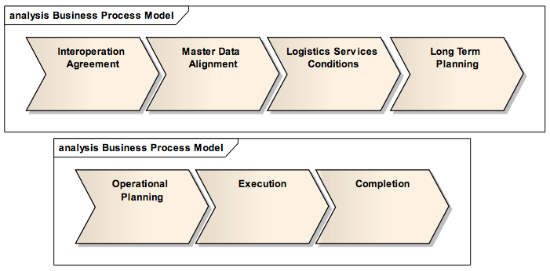

Figure Business processes

* *Interoperation Agreement* is the process that results in an overall agreement between Logistic Services Provider and Client. It is a process that essentially is performed once, or whenever changes are needed. It defines coverage of services (warehousing, transport, etc), principles and responsibilities regarding all activities. Important elements are: master data management, capacity management, service delivery, frequency of rate review, payment, claims, systems security, confidentiality/non-disclosure agreement, traceability requirements, service levels (and other performance measures), quality management, requirements and escalation procedures. It also defines the technical and administrative mechanism by which integration between Logistic Services Provider and Client will occur, including standards used, performance expectations, back-up procedures and data privacy.
* *Master Data Alignment* includes definition of the items, locations and other relevant attributes used in the logistics execution to ensure that both parties have the same and unambiguous understanding of this basic supply chain information. This process takes place periodically (once per year, for example, of when changes makes it necessary)

* *Logistics Services Conditions* describes the commitment between the Logistic Services Provider and Client on execution of the agreed services for a given period and at the stated rate / price. The Logistic Services Conditions define the relevant contractual data to be able to invoice the logistic services rendered. It does not intend to cover the totality of the contractual data (ref. the Interoperation Agreement). This process takes place periodically.
* *Long Term Planning* focuses on capacity planning Logistics Services Providers for all types of services based historic information, already agreed contracts (and bookings) and forecasts from Logistics Services Clients. This process takes place periodically.
* *Operational Planning* leading to the final agreement on logistics services to be used (one or several in combination) and the associated terms and conditions. If Interoperation Agreement, Master Data Alignment and Logistics Services Conditions have been agreed between Logistics Services Provider (LSP) and Logistics Services Client (LSC), terms and conditions from these are being used as a basis for operational planning. If no such agreements exist, more in-depth negotiation between LSC and LSP may be required.

Interaction between Logistics Services Provider and Transportation Network Manager may take place during Operational Planning, such that the condition and capacity of the transportation infrastructure may be taken into account in the planning process. Initial reporting to the Transport regulator may also take place.

Operational planning is performed continuously.

* *Execution* is about performing the services that have been agreed between LSC and LSP, monitoring their performance, quality and security and providing information about status when agreed (on request, regularly or if there are deviations). During Execution there will be interaction with Transport Regulators and possibly Transportation Network managers.
* *Completion* includes the activities necessary to complete the logistics assignment and includes all forms of reporting, agreeing claims if any and financial settlements.

# Interoperability

The term interoperability means different things to different people and organisations.

The GS1 initiative uses the term “business interoperability”:

* *“Business interoperability is the capability to run business processes seamlessly across organisational boundaries. Interoperability is achieved by understanding how business processes of different organisations can interconnect, developing the standards to support these business processes efficiently and by specifying the semantics of messages exchanged between the organizations to support these business processes in a scalable way.”*

In line with the definition of roles in Section 3.3, this definition leads to harmonisation of the interaction between the Logistics Services Client and the Logistics Services provider. Details about the supply (transport) chain employed by the Logistics Services provider are not part of this interaction.

Another definition of interoperability, particularly related to the use of ICT system is: the ability of two or more systems or components to exchange information and to use the information that has been exchanged. The focus on the *use* of information demands that both the syntax and the semantics of the information that is exchanged need to be perceived in the same way by all those exchanging the information.

The term used for interoperability in this Common Framework is leaning to the latter. If costs for connecting to a Common Framework are to be kept as low as possible, business process harmonisation should be kept to an absolute minimum, leaving stakeholders as much freedom as possible to structure their own activities.

# ICT Systems Involved

## Overview

ICT systems in freight transport management may be divided into the following three groups:

* Systems used by individual transport companies (or terminal operators) to manage their own (or in-sourced) resources and carry out transportation tasks for their clients. Such systems are typically sufficient if transportation is carried out from origin to destination using a single mode (or better, a single transport vehicle).
* Systems used by companies that organises transport operations involving more than one mode and/or involving the participation of more than one transport company. Such systems may be called supply chain management systems or transport chain management systems – depending upon the scope of functionality. In this paper this type of system will be referred to as transport chain management system TCM system.
* Systems essentially used by authorities to receive information about future and ongoing transport operations. This group also includes systems that are used for traffic management (also providing information about infrastructure capacity used by Logistics Services Providers). Such systems are used on a local level - Port Community Systems (PCS) being one example ( these systems are also used for communication between authorities and commercial stakeholders in and around the port), national level – is where National Single Window (NSW) systems are being applied, and regional or European level – Safe Sea net being one example.

These groups are illustrated in Figure 3.

In the example in Figure 3, the individual providers of single transport services have their own legacy systems for bookings etc and fleet management. The initial rail, terminal, and maritime transport services are managed as one composite service by an organisation (freight forwarder, logistics integrator) using a Transport Chain Management (TCM) system. The terminal at port of discharge, the second rail, the logistics terminal (with a warehouse) and the truck transport is organised by another company using a second TCM system or a Supply Chain Management (SCM) system dependent on the situation. The complete door-to-door transport operation (connecting the two smaller chains) is organised by a third company using its own TCM or SCM system.

When dealing with interoperability, there is little need to describe or discuss the inner workings of the transport legacy systems or the individual TCM systems. However, how these systems interact (interoperate) is of crucial interest. In state-of-the art implementations, these systems interact as indicated in Figure 3, when proper governance is adhered to. With emerging technologies, for examples those that are applied in the EU project Euridice - dealing with cargo that is self-aware, context-aware and connected, communication paths may change, but the governance structure must still be obeyed.



Figure ICT systems in supply (transport) chain management

The Logit D2D prototype developed in the D2D and FREIGHTWISE projects is one example of a TCM/SCM system. Applications developed in EURIDICE have similar capabilities.

Logit 4SEE® is a commercial product[6] based on the Logit D2D prototype, and the change of name reflects a more integrated offering but also addresses branding issues. As part of DiSCwise, Logit 4SEE® is implementing new features in order to be able to execute the pilots and comply to the Common Framework.

TCM systems need updated information about status of progress, cargo, load unit, etc. These systems may obtain such information directly, or they may obtain it from systems that are specialising in “supply chain visibility”. Such applications have been developed in projects like INTEGRITY and Smart_CM.

Systems used for reporting to authorities exist also on different levels. On the local levels we find a variety of systems at points of transhipment, Port Community Systems (PCS) being one example. They are used for receiving all forms on information about vehicles and their cargo and are being used partly to collect and convey information to authorities and partly for adapting and sending information to various other stakeholders in and around the transhipment point (terminal, port, etc).

A number of authorities are in need for information about vehicle movements and cargo, and national Single Window systems have been developed for this purpose; this is the national level in Figure 3. In some situations, the local level (PCS is again an example) systems may provide the single window interface.

On a regional (European) level, we find systems like the SafeSeaNet, which collects information about ship movements all around Europe, based on reports form individual Member States.

## Governance

Governance is about accountability for consistent, cohesive policies, processes and decision rights[7]. In relation to the Common Framework, it is important to be aware of the “lines of responsibility” between the parties that are involved in the management of transport and supply chains; see Figure 4.



Figure Line of responsibility

It should be recognised that, regardless of circumstance, a Logistics Services Provider is undertaking a transport or logistics services under contract with (on behalf of) the Client. In situations where there is the need for more than one service to satisfy the need of the Client, there may be more than one “level” in this “line of responsibility”, as illustrated in Figure 3.

## Interactions

One must not be led to believe that, even though governance and “line of responsibility” are important, that all exchange of information take place only along the “line of responsibility”. Section 0 describes a scenario derived from practical application of results from previously mentioned EU funded projects. It is easy to spot areas where information exchange does not seem to follow the “line of responsibility”.

Example 1: A Freight Forwarder (in the role of Logistics Services Client) is subcontracting a trucking company (in the role of Logistics Services Provider) to bring cargo from a manufacturer to a port. In order to make the port operation smooth, information about the identity of the truck, driver, the arrival time etc need to be sent to the port from the trucking company and information about parking space and other relevant information need to be sent from the port to the trucking company. The practical exchange of information here is directly between the trucking company and the port. This may seem to breach of obeying “line of responsibility”, but when the Freight Forwarder has accepted that such exchange is acceptable then it is OK. Other wise, all communication need to take place via the Freight Forwarder.

This is typically a situation where a Port Community System is being used for information exchange to commercial stakeholders around the port.

Example 2: The Smart_CM and INTEGRITY project deal with security and visibility of intercontinental container transport (short descriptions of the results of these projects are given in Section 13). In these projects the shipper (Logistics Services Client) is acquiring the container seals and ensures that they are being mounted, initiated and set up for communication. In principle, the information from the container seals should go directly to the proper authorities (at each end of the intercontinental transport service). However, the information provided by such seals has also valuable logistics information and may be set up to communicate such information to other stakeholders (the neutral layer – well illustrated in Section 0 and Figure 30). Such direct communication is efficient and practical, but agreements need to be set up in order to ensure that communication between stakeholders is properly performed.

# The Common Framework

## Introduction

In this document a Framework is considered a common basis on which current and future EU projects may build in order to provide added value in the form of interoperable functions and lack of duplication of efforts. Furthermore, properly deployed, the Common Framework should facilitate improved interoperability between the information systems used by all stakeholders in transport and logistics.

Since the stakeholders have been divided into a set of roles, the Common Framework will be defining the information that need to be exchanged between the roles such that each and every one is able to perform the functions associated with the roles as efficiently and effectively as possible.

## Framework Requirements

On the basis of the projects already mentioned, a list of requirements for a Common Framework has been identified:

* Support multimodality (co-modality)
* Be stable and easy to refine and expand
* Be future-oriented (independent of current solutions)
* Provide a total picture (supporting transparency, management, and security)
* Facilitate hiding of complexity (abstraction, simplification)
* Focus on interoperability (not on inner parts of systems)
* Independent of technology
* Facilitating interaction with existing standards (to help protect investments already made in legacy and other systems)

Further requirements that have been extracted in the process leading up to the development of this document are as follows:

Different stakeholders have their own strategies and objectives and will have to be given the possibilities to continuously develop these. As a consequence, the Framework needs to:

* Assist in making the European transport and logistics system more efficient and environmentally friendly
* Provide interoperability without constraining business process development and improvements
* Lower barriers to improve business processes and develop new business models. The document “CO3: Collaboration Concepts for Co-modality”[8] expresses a situation where the transport and logistics industry needs to develop business processes over time until the goal of ensuring the best possible use of all transportation resources has been reached.
* Simplify interaction with authorities and compliance. For the time being there are different requirements for compliance and reporting for different modes and different geographies.
* Unlock access to services that would not be available without it.
* Enable market leaders and SMEs to interact at a low cost, and this should emerge as a standard endorsed and adopted by major freight ICT systems providers and logistics operators. Stakeholders that already have invested significant in existing ICT systems and associated technologies should be able to further exploit these investments and not replace them.

## Scope

One of the challenges relating to developing a Common Framework is to define its scope in reaction to the requirements identified previously, where it is possible to efficiently map, harmonize and integrate different solutions for ICT in transport logistics.

To map solutions, two main dimensions are being used:

1. The solution target users, corresponding to the main stakeholders involved in transport logistics processes, represented by the roles that were defined in Section .
2. The level of specification, ranging from high-level organizational concepts, via processes and information structures (from ontologies / semantic frameworks down to definitions of web services and message schemas) to physical implementations involving, e.g., on board devices (vehicles, load units, and cargo) and infrastructure networks.

The resulting matrix is illustrated in . It should be noted that here the roles of Consignor and Consignee are not included. The reason for this is that these two roles are, from the Common Framework point of view, “hidden” inside the Transport Demand domain, see Section 6.4.



Figure Logistics stakeholder and capabilities matrix

Selected capabilities included in the matrix are:

* **Goods Identification** provided by global, public domain services and standards, such as GS1 EPC, and supported by seamless integration and communication between user, vehicle and cargo-related devices. A key feature is the ability to dynamically select and relate the level of detail across various hierarchies of load units (package, pallet, container ...). Technologies employed are essentially bar codes with readers. RFID tags are coming into play, but the uptake is dependent upon the capability for the technology total to provide more than just identification (as already performed by bar coding).
* **Context determination**, provided by a common infrastructure relating and supplying context data (e.g., vehicle and infrastructure, location, time, goods status) to authorised users. The key feature is to acquire and cross-reference contextual information from a variety of sources, including infrastructure sensors, hand-held devices and vehicle on-board units.
* **Process-/Cargo-centric services platforms,** providing access to information services to users/actors, devices and systems interacting with processes and with the cargo. A key feature is the ability to combine services from different sources, including, e.g., traffic management systems, fleet management and shippers’ supply chain management systems. Included are (i) process-centric services that focus on planning and execution of logistics processes, and (ii) cargo-centric services that collect and make available cargo related information (which may be sensitive) under defined authorisation policies.
* **Decentralized processing**, provided by cargo proximity devices (e.g., active tags, intelligent sensors, ZigBee devices) able to start processes locally, to invoke remote services and trigger actions, e.g., by rising alerts. The key feature is the cargo ability to act by dynamically accessing the communication and computing resources available in the current context, e.g., on-board devices, vehicle-infrastructure communication infrastructures.
* **Vehicle-Infrastructure communication**. The CVIS project[9] provides a four-layers architecture for vehicle-road infrastructure communication consisting of: communication infrastructure, enabling continuous connections over different carriers (e.g. IR, DSCR, M5 and 2G/3G), execution infrastructure middleware based on OSGi, user application layer and common services facilities.
* **Traffic management services**. Until now, Cooperative Systems (meaning cooperation between systems related to infrastructure and vehicles) have been essentially applied to traffic management services focused on safety and infrastructure efficient use. Nevertheless several of the existing facilities and applications can be used in the freight context, e.g., for monitoring, traffic management information, access control and parking zones applications aimed at logistics operators.
* **Information exchange – messages**. For all practical purposes, the use of electronic messages, where used, replaces the exchange of freight related information previously done on paper. In principle, previous paper documents were converted to electronic documents, which have resulted in a large set of different, highly redundant message definitions, and implementations that do not properly support interoperability.
* **Processes**. In this document, the term process means “business process”. The challenge related to the Common Framework is to facilitate that only minimum business process coordination is required in order to achieve efficient and effective cooperation between parties in co-modal logistics.

Using the two dimensions illustrated in Figure 5, a mapping is possible of current solutions in EU ICT (represented by the EU funded projects that contributes to this document):

* e-Freight, dealing with efficient freight transport management from door-to-door (involving Logistics Services Clients and Logistics Services Providers, but also interacting with Transportation Network Managers (for obtaining appropriate information about infrastructure availability and capacity) and Transport regulators (like customs and other administrations. The projects under the e-Freight umbrella are: FREIGHTWISE, e-Freight, SMARTFREIGHT, RISING, and DiSCwise. These projects address essentially harmonisation and standardization issues in relation to high-level concepts such as information messages, processes and organization. SMARTFREIGHT and RISING also have strong links to Cooperative Systems, while the e-Freight project has strong links with Compliance activities - see below.
* Intelligent Cargo, where research was initiated in the EURIDICE project, addresses technological platforms enabling the cargo to play an active role in logistics processes, by delegating information and functions to tags and devices travelling with the cargo itself. Intelligent Cargo is transversal to the roles, but it is presently being piloted mainly by users/clients and services providers.
* Supply Chain Security and Compliance, represented by Smart_CM and INTEGRITY, addresses the security needs of logistics services providers and transport regulators in relation to all aspects required. It should be noted, however, that in the FREIGHTWISE project, the Transport Regulator also has the responsibility of verifying compliance. Hence, in the following analysis, this domain will be called Supply Chain Security and Compliance.
* Cooperative Systems, represented by projects like CVIS, COOPERS, and – in the logistics field – by SMARTFREIGHT, address the communication and interaction between vehicle, drivers and infrastructures for the purposes of traffic flows management.

The resulting mapping is as shown in Figure 6.

The following figure summarizes how the individual projects have covered specific domains[10]:

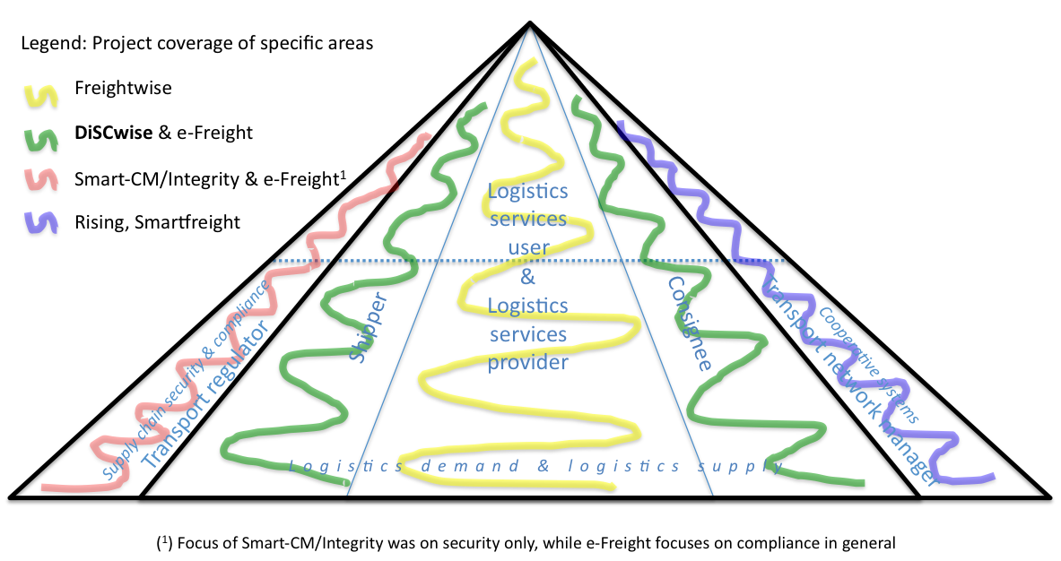

Figure Domain coverage by projects

The projects **E-Freight and DiSCwise** had as an additional role that these projects provided a *holistic* perspective, integrating the various initiatives into the Common Framework. In that context,

**DiSCwise** is paying particular attention to SMEs and how they can take part in a digital supply chain. Moreover, DiSCwise aims to bridge the gap to real-life implementations and to push towards critical mass implementation. The DiSCwise pilots should demonstrate and pave the way for easy, affordable ICT adoption to increase the efficiency of the sector.

After careful considerations, the areas covered by e-Freight, Intelligent Cargo, Supply Chain Security, and Cooperative systems provide the scope for the Framework that will be presented here and further developed in the ongoing projects and in the actions that are proposed later. The resulting domains are illustrated in Figure 7 and explained in Section 6.4. See specifically Section 6.4.5 regarding Intelligent Cargo.

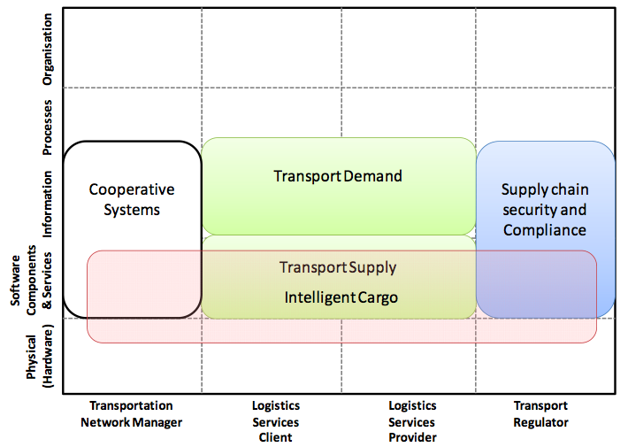

Figure Domains plus Intelligent Cargo

## Domains

### Cooperative Systems

Cooperative systems, by some called traffic management systems, deal with the interaction between vehicles and the infrastructure, and there are different systems for different modes. By having all the interactions being inside the cooperative systems domain is a simplification. The vehicles are operated by Logistics Services Providers. Hence, the cooperative systems domain should cover both Transportation Network Manager and Logistics Services Provider. For the purposes of the Common Framework, this simplification does not have any significance, since the Common Framework deals with logistics and not traffic management.

All the mode-orientated initiatives from the EU Commission fall into this category:

* River Information Services (RIS)[11] dealing with inland waterway transport
* Intelligent Transport Systems (ITS)[12] dealing with road transport and interfaces to other modes (which refers to e-Freight)
* TAF TSI (Telematic Applications for Freight – Technical Specification for Interoperability) Regulation[13] focused on rail.
* e-Maritime[14] dealing with business in the maritime sector with the support of advanced electronic capabilities

The maturity in these areas is different. However, standardisation has been developing for quite some time in some of them, and within these domains, there is no reason for a Common Framework as suggested here to “intervene”.

What is of interest, however, is the information within the Cooperative Systems domain that is of interest in the area of e-Freight. This will be described later in the document.

### Transport Demand

Transport Demand is the domain of the following roles:

* Consignor
* Consignee
* Logistics Services Client

The domain deals with all activities defining the need for transport and identifying the appropriate services (in industrial transport mostly based on pre-existing agreements).

Where there exists an order between Consignor and Consignee, information about the need for transport may be extracted from the order.

### Transport Supply

Transport Supply is the domain of Logistics Services Providers and may be divided into the following three sub-domains:

* **Commercial Operations Management** deals with handling all interactions with Logistics Services Clients. In performing these activities there is close interaction with
* **Transport Operations Management** makes sure that all transport and logistics operations agreed with Logistics Services Clients are being performed as agreed, with the best possible use of resources.
* **Vehicle, equipment and cargo operations** deals with all operations related to movement of vehicles, operating cargo handling equipment (cranes etc.) and cargo (including load units).

### Transport Chain Security and Compliance

Transport Chain Security and Compliance is the domain of the Transport Regulator. All activities that are directed to setting up and monitoring adherence to rules and regulations belong to this domain. One example is monitoring movement of dangerous goods. Another is customs clearance. A third task is related to security along the supply chain.

### Intelligent Cargo

As can be seen from Figure 6, the domains of Cooperative Systems, Transport Demand, Transport Supply and Transport Chain Security and Compliance are quite disjunctive, while Intelligent Cargo overlaps with three of the domains.

Based on the discussion going on in the LinkedIn Intelligent Cargo Forum about the definition of “intelligent cargo”, the most recent suggested definition is:

*Intelligent Cargo is cargo that holds information about itself and is able to process and communicate that information to stakeholders across supply chains.*

In relation to the question above, this definition leads to a conclusion that intelligent cargo drives at implementations and that aspects related to intelligent cargo leads to technical and technological architecture issues, rather than to conceptual framework definitions. The business processes that are described in Section 3.3 are in line with those that were taken into account in the EURIDICE project.

## Interactions between Domains

As stated previously, the Common Framework should leave companies as much freedom as possible to organise activities and designing business processes. Hence, the focus is on interaction between the different domains (or roles belonging to the domains).

### Interaction between Transport Demand and Transport Supply

In the standards offered by the standardisation organisations listed in Section 14, the principle has been that each of the transport and logistics documents that were used in the past (on paper) have been converted into electronic documents. The result is large number of electronic documents with much redundancy.

During the FREIGHTWISE and e-Freight projects there have been continuous discussions within the projects and between project participants and representatives from the logistics industry. The latter states that “all” needs identified in the processes Operational Planning, Execution, and Completion can be met by a well defined “Transport Execution Plan” package and an associated Status message.

A similar conclusion was reached in FREIGHTWISE, where the “Transport Execution Plan” was developed to handle all the exchanges between Logistics Services Providers and their Clients related to individual transport services. Hence, the Common Framework will be based on this principle.

It has been apparent in the dialogue with industry that some of the terminology used in FREIGHTWISE is not the best basis for providing proper understanding. Hence, some terminology adjustments are needed. The new terminology is applied here.

Hence, two of the information packages, or messages, which are exchanged between the roles illustrated in Figure 4 are:

* **Transport Execution Plan (TEP)** – This contains all the information needed for a Logistics Service Client and a Logistics Services Provider related to the execution of a transport service. A Transport Execution Plan can be developed through several steps, or it can be created in one step only. This depends on the agreements already in place between the Logistics Services Client and the Logistics Services Provider, and the complexity of the service to be executed. The execution of a service can start when the Transport Execution Plan is marked “Ready for Execution”. A Transport Execution Plan is identified by a unique identifier, valid for the relationship between a given Logistics Services Client and a given Logistics Services Provider. The structure of the Transport Execution Plan is illustrated in Figure 8[15].
* **Transport Execution Status (TES)** – The Transport Execution Status information package gives the status for a Transport Execution Plan. The identifier of the Transport Execution Plan is needed. The status is marked as Boolean, either there is a deviation, or not. If there is a deviation, the identifier(s) of the transport item(s) causing the deviation is given. If there is deviation on a Transport Execution, this information package gives the status of the involved transport item(s). The type of deviation is given. The structure of the Transport Execution Status is illustrated in Figure 9[16].

|  |  |
| --- | --- |
| Figure Structure of the Transport Execution Plan | Figure Transport Execution Status |

When the Framework is developed, it is important that the information that is exchanged enables all stakeholders to perform well. Hence, information needs to be necessary and sufficient. The two messages described above are necessary, but two more are needed in order to make the communication between Transport Demand and Transport Supply Complete:

* **Transport Service Description (TSD)** – This is the information that any Logistics Services Provider needs to communicate to Logistics Services Clients (potential clients) such that they may use the information about the service provided when the need for transport has been established. This is an attempt to define a standard way of describing transport services such that they will be “searchable” and such that individual services may be automatically connected into transport (supply) chains. The structure of the Transport Service Description is illustrated in Figure 10[17].
* **Goods Item Itinerary (GII)** – All door-to-door transport operations using more than one mode of transport, and many of those that use only one mode, are not direct services being provided without transhipment. Hence, it is necessary to be able to describe the complete itinerary for a given goods item. The Goods Item Itinerary provides this capability and the planned, estimated, and actual times for departure and arrival for each service, or segment is included. This means that information in the GII may later be used to trace the exact movement of goods through a supply chain. It is communicated from the Logistics Services Provider to Logistics Services Client when the Transport Execution Plan is marked “Ready for Execution”. The structure of the GII is illustrated in Figure 11[18].

|  |  |
| --- | --- |
| Figure Transport Service Description | Figure Goods Item Itinerary |

### Communication between Logistics Services Provider and Transport Regulator

#### Introduction

It is not the purpose of the Common Framework to provide any form of standard within the Transport regulator’s domain, previously termed “Supply Chain Security and Compliance”. However, communication between the Transport Supply and the Supply Chain Security and Compliance domains are important and will be addressed here.

The projects INTEGRITY and Smart_CM both deal with the issue of Supply Chain Security. However, in addition, to make this issue useful for actors, elements of supply chain visualisation and logistics status reporting have been included in the respective ICT systems developed in the two projects.

From INTEGRITY and Smart_CM, there are strong indications that the messages developed in FREIGHTWISE and presented in Section 6.5.1 can be used when it comes to reporting the status of the logistics operations, even though neither project has attempted to use the appropriate FREIGHTWISE messages for this. The systems for value-added services in both projects are configurable and adaptation to Common Framework is straightforward.

However, FREIGHTWISE has not been engaged in the security aspect, and this needs to be covered by the Common Framework.

#### Supply Chain Security

The focus here is the provisioning of information that enables customs authorities to release the container from the terminal in the port of discharge within the EU. Note that Smart_CM and INTEGRITY have focussed on releasing the container from a security perspective – but also the release by customs from a fiscal perspective and the commercial release is to be taken into account in an integrated manner.

The information required for a security release is based on three pillars:

1) Authorized economic operator status of the involved economic operators. If alternative certification regimes are used, the customs authorities involved need mutual recognition of each others control mechanisms.

2) Provision of summarized cargo information (describing the content of a container). This can be based on the Entry Summary Declaration (ENS) provided as part of the Import Control System (ICS). If possible, this can be complemented with purchase order and/or invoice information. This information supports Customs Authorities in performing risk management.

3) The use of security devices on containers and other relevant load units, in this document termed Container Security Device (CSD).

The CSD holds the following information (capabilities dependent):

* Event – representing the last status of the CSD
* Unit – unique load unit ID
* EventSensor – measurement of temperature, humidity, etc.
* Location – informing about location and speed of movement
* Device – device ID
* Reader – ID of device reader if the device is not capable of sending by itself
* User – ID of partner that attached the device
* Technology – reference to provider of the device
* References – the secure trade lane used

The reference to the secure trade lane determines the itinerary: The services to the used and corresponding schedules.

The event can be used to determine the container integrity status, with the following states:

* + Secure (GREEN): The container has not been reported breached and cannot be intruded.
  + Endangered (YELLOW): The container has not been reported breached but is vulnerable for intrusion.
  + Intruded (RED): The container has been reported breached.

All relevant information regarding itinerary is available in the Common Framework messages described in Section 6.5.1. However, there is a need to communicate the CSD status, and for that purpose the Smart_CM project has developed a Security Data Message (SDM).

The format of the SDM (SDMF) defines a standard format for data provided by CSDs, enriched with a reference to a MRN (movement reference nr) assigned by customs authorities as part of the so-called import control system (ICS) procedure[19].

The Smart_CM project has established a CEN workshop[20] for the SDM in the process of making this a standard.

As soon as Transport Execution starts (more specifically after activation of the CSD), the CSD starts transmitting.

#### Compliance

Compliance is about reporting information about transport to customs and other authorities, reporting to SafeSeaNet being one example.

The Common Regulatory Schema (CRS) is meant to be the mechanism for such reporting. The Common Regulatory Schema is still under investigation in the e-Freight project[21], but the essential information needed for such reporting is in the Transport Execution Plan message.

Through the INTEGRITY and Smart_CM projects it is clear that the World Customs Organisation (WCO) data model will have to be taken into account when the Common Regulatory Schema is being finalised. Furthermore, the SDM presented in the previous section may need some adaptations.

### Communication between Logistics Services Provider and Transportation Network Manager

#### Transportation Network Status

In the FREIGHTWISE project, a message called Transportation Network Status (TNS) was defined with the purpose of have one standard information package that might be used by Logistics Services Providers when planning transport operations. It would cover information such as the real capacity of transport infrastructure, weather, etc.

In FREIGHTWISE, business cases led the project to direct its attention to road transport for the TNS, and the first version was strongly influenced by DATEX.

As the FREIGHTWISE TNS message was attempted to be used in the RISING project, it soon became clear that other messages containing similar information had progressed in standardisation as a part of the RIS developments.

After careful consideration, it has been concluded that even if the concept of Transportation Network Status is an important one, to try to make one, common mode independent message for providing Transportation Network Status at this stage will be counterproductive.

The Common Framework should at this point have the TNS point to the mode specific messages for providing such information. Examples are: road – DATEX and on inland waterways – Notices to Skippers - as being used in RISING. Similar information is available in the TAF/TSI community and will be properly developed in the e-Maritime initiative.

#### Transport Operation Status

Reliable information about Estimated Time of Arrival (ETA) is crucial for proper logistics management. Normally such information is exchanged between Transport Operation Management and Vehicle, Equipment and Cargo Operations. In other words, the one responsible for operating a vehicle is the one responsible for providing reliable ETA. However, there may be situations where updated information about infrastructure capacity is needed for calculating ETA properly. Such information is normally not available onboard a vehicle. The Transportation Network Manager, however, holds such information.

To facilitate cooperation between Logistics Services Provider and Transportation Network Manager in establishing the best possible ETA, the Transport Operation Status Message was defined.

The Transport Operation Status message contains information about an identified transport means, and provides information about its current location and arrival and departure details at this location, as well as details related to subsequent arrivals and departures along the route (locations and times) for this transport means; see Figure 12[22].



Figure Transport Operation Status

## Intelligent Cargo

Intelligent Cargo is an architectural approach that builds on distribution of information and computational resources with the purpose of “making cargo information services available to the mass of potential users, by lowering adoption barriers related to cost, effort and information system requirements” [23]. This is done through a technological infrastructure supporting some key capabilities in our framework scope as defined in 6.3, including identification, context-detection and cargo-centric services (Figure 13).



Figure Intelligent Cargo Capabilities

The architecture proposed by the EURIDICE project to support Intelligent Cargo capabilities includes the following main components:

**ecNodes**

To reduce complexity all business objects (cargo, means of transportation, services and human-operated devices) are represented by the abstract concept of an EURIDICE Compliant Node (pronounced like *“easy node”)*. An ecNode can be uniquely identified and has a reference to an Information provider where more information can be found when authorised.

**Intelligent Cargo Network**

The primary goal of the EURIDICE architecture is to implement the Intelligent Cargo Network, formed by identified cargo objects, cargo-centric information services and agents to assist the exchange of cargo related information:

* The **Assisting Cargo Agent** is a special kind of information provider and part of the Intelligent Cargo Network. It is a single point of access for the exchange of information about cargo and acts like a virtual reception that can also help when there is temporary no communication with the cargo item itself.
* While the Assisting Cargo agent represents the cargo in the virtual word, the **Operation Cargo Agent** assists the cargo item in the physical world by interacting with other objects and allowing information access. The Operational Cargo Agent can also use local computational resources to take proactive initiatives to provide real-time relevant information and actions, e.g., for measurements to be taken in real time. Cooperation with other nearby intelligent cargo items by sharing measurements for instance, is another capability.

When it is too expensive to equip cargo with a smart device to host an Operational Cargo Agent, this functionality can be delegated to a nearby mobile ecNode, for instance the onboard unit of the truck or train the cargo is travelling on.

**Virtual Service Point**

Information and services can only be accessed through a Virtual Service Point where security will be enforced and communication services are hosted to enable *one common open platform* and to support a *secure peer-to-peer network.* Authorised information and requests for information will be routed to the applicable services. Also gateways and adapters are hosted here to connect business specific end-user-applications and legacy systems.

**Semantic framework**

The EURIDICE approach requires a Common Framework, as the one proposed in the present paper, to provide shared data-models, process and message definitions. The role of this semantic framework is crucial in that it not only supports the core Intelligent Cargo services but also all business specific services including business specific end-user-applications and legacy systems.

**Hierarchical positioning**

Based on a unified model for “location” and the Intelligent Cargo Network infrastructure, hierarchical positioning across business domains can be realised. This means for instance that the position of a cargo item equipped with nothing more than a barcode can be monitored because of the known relation with the pallet it is on, the container where the pallet is stored in and the known position of the truck that is moving the container.

**Context detection**

The ability of cargo to interact with other objects and devices in proximity, and the availability of a common ontology and data models, allow services to detect, and relate to, the current context of cargo items. In this way, cargo tracking and sensor measurements can be enriched with dynamic access to services that take into account the current cargo context and interacting entities like, e.g., carrier, infrastructure and ruling authority.

**Cargo Intelligence**

Cargo Intelligence and global reasoning is another key feature of the architecture. Based on a standardised knowledge structure (ontology) extended with rules, relations and actual measurements (facts), trend and unusual deviations can be determined. Beside support for remote users decision-making, this technology can also be used for support decisions on the field, assist the intelligent cargo itself and human operators.

**Orchestration**

The EURIDICE architecture provides a mechanism for orchestration of services across business domains to increase cooperation between the stakeholders of the Supply chain. This allows combination of infrastructure, user-defined and legacy systems functionality into coordinated processes, supporting development of highly specialized applications for mobile and fixed users.

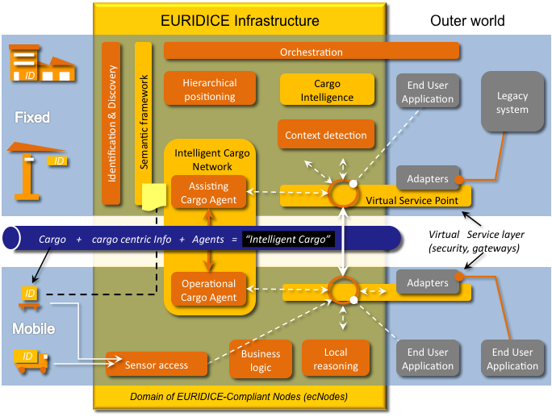

Figure EURIDICE Intelligent Cargo Architecture

## Mapping between the Common Framework and other standards

The following sections map the Common Framework to other standards. In this mapping we will look at roles, business processes, messages and individual data items. In case of detailed mapping of data items, reference will be made to appendices.

Included at the moment are mappings to GS-1 LIM and OASIS UBL. Other mappings, including UB/CEFACT/TBG3 will be included as part of ongoing work planned.

### Common Framework mapped to GS1 LIM

This mapping is based on Logistics Interoperability Model Version 1 Issue 1.0 d.d. August 2007.

#### Roles

|  |  |
| --- | --- |
| ***Mapping section: Roles*** | |
| **Common Framework** | **GS1 LIM** |
| Consignor | Consignor |
| Consignee | Consignee |
| Logistics Services Client | Logistics Services Client |
| Logistics Services Provider | Logistics Services Provider |
| Transportation Network Manager | N/A |
| Transport Regulator | N/A |

#### Business processes

|  |  |
| --- | --- |
| ***Mapping section: Business processes*** | |
| **Common Framework** | **GS1 LIM** |
| Interoperation Agreement | Interoperation Agreement |
| Master Data Alignment | Master Data Alignment |
| Logistics Serivces Conditions | Logistics Services Conditions |
| Long Term Planning | Planning |
| Operational Planning | Transport / Warehousing |
| Execution |
| Completion |

#### Messages

|  |  |
| --- | --- |
| ***Mapping section: Messages*** | |
| **Common Framework** | **GS1 LIM** |
| TSD Transport Service Description | N/A |
| TEP Transport Execution Plan | Transport Instruction / - Confirmation[24] |
| GII Goods Item Itinerary | N/A |
| TES Transport Execution Status | Transport Status Request / Notification[25] |
| TOS Transport Operation Status | N/A |
| SDM Security Data Message | N/A |
| CRS Common Regulatory Schema | N/A |
| TNS Transportation Network Status | N/A |

#### Data elements

A detailed mapping, on data element level, between the TEP and the Transport Instruction / Transport Instruction Confirmation messages is being drafted at the moment. Please refer to the draft document “TEPvsTI.docx”. References to formal documents, being delivered as part of the e-Freight project, will be included when available.

A detailed mapping between TES and Transport Status Request / Notification is pending within the e-Freight project.

### Common Framework mapped to OASIS UBL

This mapping is based on UBL 2.1 Public Review Draft 1 (PRD1) d.d. 25 September 2010. This will be updated after publication of UBL 2.1 Public Review Draft 2 (PRD02).

#### Roles

|  |  |
| --- | --- |
| ***Mapping section: Roles*** | |
| **Common Framework** | **OASIS UBL**[26] |
| Consignor |  |
| Consignee |  |
| Logistics Services Client | Transport User (TU) |
| Logistics Services Provider | Transport Service Provider (TSP) |
| Transportation Network Manager | Transportation Network Manager |
| Transport Regulator | Transport Regulator |

#### Processes

|  |  |
| --- | --- |
| ***Mapping section: Business processes*** | |
| **Common Framework** | **OASIS UBL** |
| Interoperation Agreement | N/A |
| Master Data Alignment | N/A |
| Logistics Serivces Conditions | N/A |
| Long Term Planning | N/A |
| Operational Planning | Intermodal Freight Management / Planning |
| Execution | Intermodal Freight Management / Execution |
| Completion | Intermodal Freight Management / Completion |

#### Messages

|  |  |
| --- | --- |
| ***Mapping section: Messages*** | |
| **Common Framework** | **OASIS UBL** |
| TSD Transport Service Description | *To be included in UBL 2.1 Public Review Draft 2* |
| TEP Transport Execution Plan | TransportExecutionPlan |
| GII Goods Item Itinerary | *To be included in UBL 2.1 Public Review Draft 2* |
| TES Transport Execution Status | TransportExecutionStatus |
| TOS Transport Operation Status | TransportOperationStatus |
| SDM Security Data Message | N/A |
| CRS Common Regulatory Schema | N/A |
| TNS Transportation Network Status | N/A |

#### Data elements

The messages TEP, TES and TOS are included as messages in UBL. This will also be the case for the messages TSD and GII in UBL 2.1 Public Review Draft 2. This implies that, per definition, all the data elements used are part of the library of reusable business data components from which the UBL document schemas are assembled. So no detailed mapping is required, since these are already UBL messages.

# Common Framework Summary

The ambition of the Common Framework is that it shall be able to communicate necessary and sufficient information between the stakeholders involved in freight transport management.

Figure 15 shows the elements of the Common Framework:

TSD Transport Service Description – a standard description of transport services suitable for automatic detection

TEP Transport Execution Plan – describing all the information needed related to the execution of a transport service.

GII Goods Item Itinerary – providing information about the movement of the goods (possibly through a chain of services)

TES Transport Execution Status – providing information about the progress of the transport and of the cargo condition

TOS Transport Operation Status – assisting in establishing the best possible arrival time estimates

SDM Security Data Message – providing information about the security of a sealed load unit.

CRS Common Regulatory Schema – providing a unified way of informing authorities about transport such that compliance may be verified.

TNS Transportation Network Status – nor suggested as a new standard, but a pointer to messages providing such information for the different transport modes.

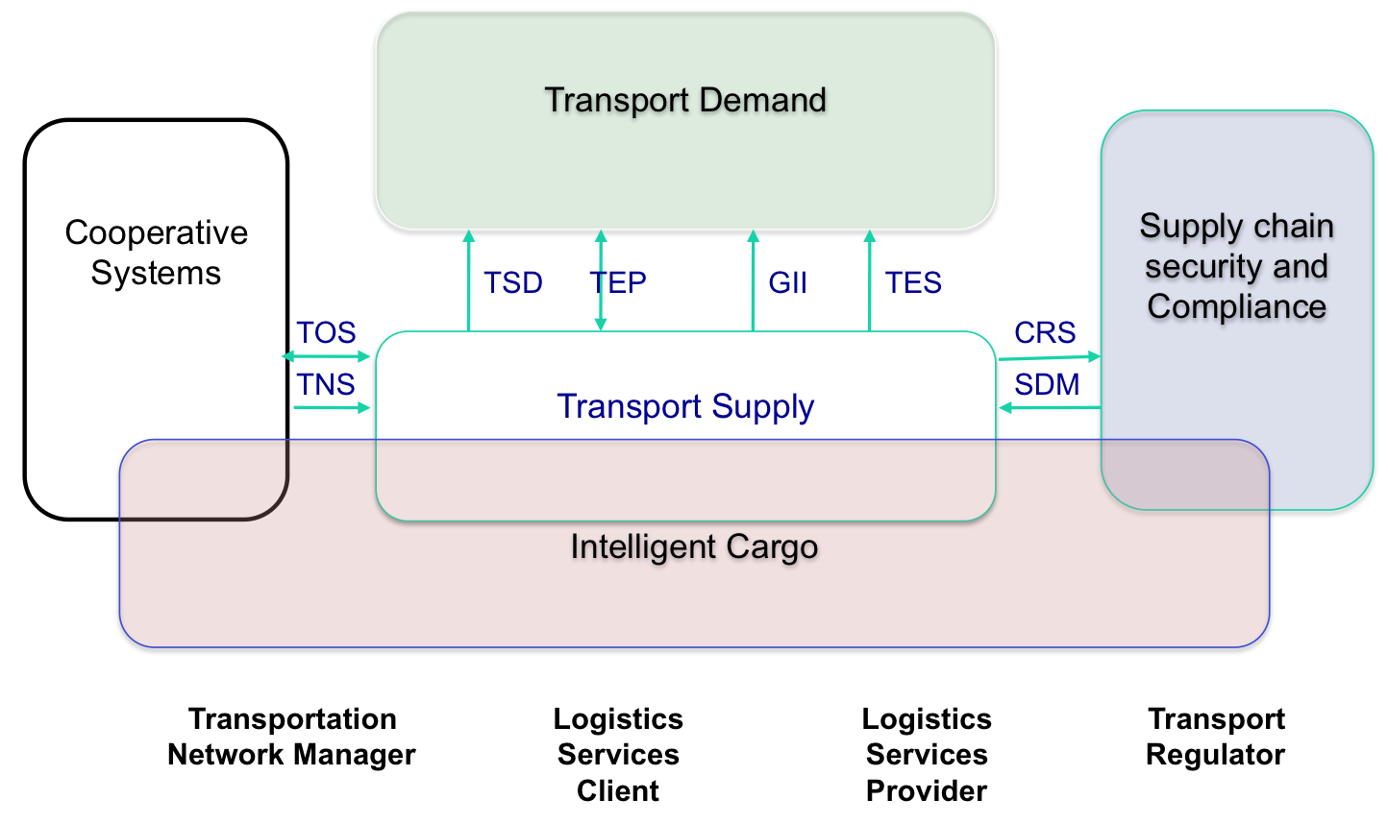

Figure Common Framework summary

# Usage of the framework

The following figure shows how the identified roles interact using the data exchange standards from the Common Framework:

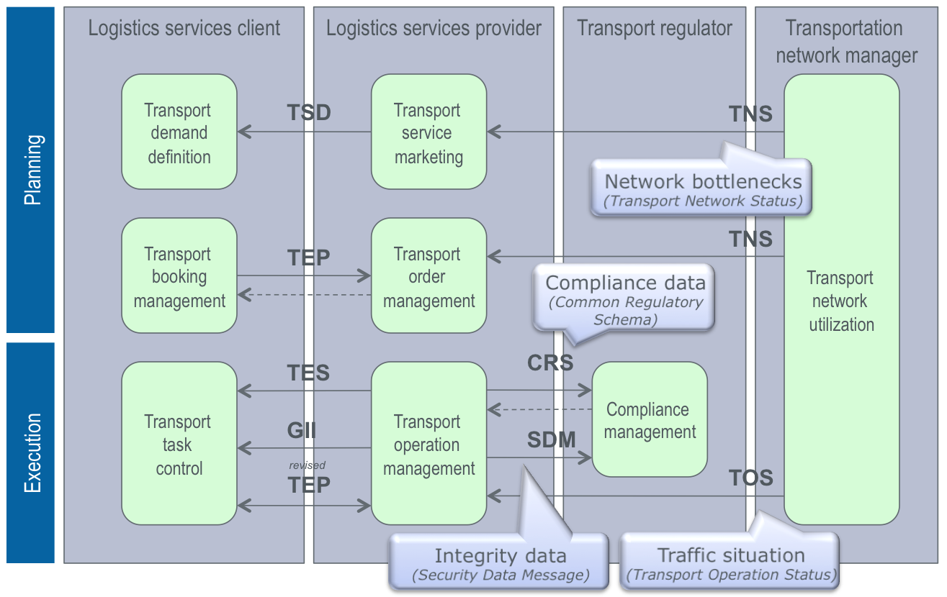

Figure Process overview

The sections below will exemplify the use by specific actors, based on actual examples:

* Section ‘Integrated Process Description’: Shows how practical actors like forwarders, consignors, carriers, agents, transport operators, terminals and customs interact in a business process that incorporates several aspects: Aligning subsequent legs in the chain, security & fiscality, co-modality, etc.

Section ‘In the end the consignee benefits from a delivery which has minimal lead time, costs or carbon footprint, and which has improved reliability which allows him to reduce safety stocks and working capital.

* Fit Between the Integrated Scenario and the Common Framework’: Shows how Common Framework standards are being used in the example of the integrated process.

# Scenario

## Scope

The common framework scenario is based on the integration of a number of individual scenarios that were demonstrated as part of separate European projects. The purpose of such integration is to join efforts and enhance the functionality and impact of these initiatives and to illustrate that the results of these individual projects can be fully interoperable. Such interoperability will be illustrated on process, systems, and data level.

Below the individual operational scenarios are identified with a statement of scope and benefits, and these will be described later in this section.

1. Sea/hinterland interfaces: This concept - which is under development on interregional level by Cargo Community System (CCS) with inland terminals/operators - focuses on better alignment of sea, terminal and hinterland legs. The scope is limited to a part of the end-to-end supply chain – starting from the arrival of the vessel to the port of discharge and ending when the containers have left the gate of the sea terminal. Benefits are partly in planning (re-planning inland transportation based on changes in closing time, better pre-stacking based on known inland mode, operator and timeslot), partly in execution (better ‘green light’ communication providing the inland operator with knowledge on customs and commercial release of containers).
2. Secure Trade Lanes: This reflects the results of the two projects Smart-CM and Integrity which have focused on secure trade lanes. Although a larger part of the end-to-end chain is covered, the focus is strongly on execution – starting from activation and ending with deactivation of the container security device (CSD). Benefits are in improved visibility and support to customs authorities to implement mechanisms for advance cargo notification and security clearance. The ICS SEAP developments within the SMART CM project will provide the these mechanisms.
3. Co-modality in Logistics Planning & Execution: DiSCwise, which is funded by DG Enterprise, focuses on real-life demonstrations of the Freightwise Framework (FWF) within a number of specific vertical market segments but always focussing on SMEs. Part of the functionality demonstrated is planning oriented. It enables the optimal *combination* of short sea shipping, rail services, barge services and road transportation in order to provide optimal end-to-end transport chains (offered as a single service) from the point of view of lead time, costs and/or environmental footprint. It starts from the shipment order and ends with with the proof of delivery. Besides ensuring optimal hinterland connections, additional benefits are consolidation potential, rescheduling of timeslots to keep the legs in the transport chain aligned optimally, and visibility of the supply chain. On top of that the accessability of the hinterland can be better utilized to its full extent based on available services (and their combination into intermodal routes). Discwise also contains the “import services” cargo data aggregation layer. Within these services Customs import manifest and status information is exchanged between the carrier, importer, freight forwarder and Customs broker to increase the efficiency of the Customs import clearance process and to add the Customs import release status to the visibility services.
4. Integrating inland navigation into the transport chain: Use of the adapted Freightwise Framework for inland waterway transport and its integration into intermodal chains. Link of the conceptual model to existing standards like ERI (electronic reporting). On this basis Event Services based on existing RIS data are being built.

The common framework scenario will incorporate (1), (2), (3) and (4). This is done in order to keep the focus on operational planning and execution of transport processes.

On top of these operational projects, the common framework scenario will use a number of *architectural* results that will be integrated in a common framework (see previous section).

1. Conceptual architecture: Based on the Freightwise project, focussing on interoperability between roles and processes in door-to-door co-modal logistics.
2. Technological architecture: Based on the Euridice project, focussing on a technological model for intelligent cargo.

The last section of this scenario description will clarify the link between the operational scenario and the common framework.

## Description of Integrated Scenario

### Sea/hinterland interfaces

This scenario finds its origin in the detailed assessment of import processes done in the Flemish ports, which exemplify generic import processes:

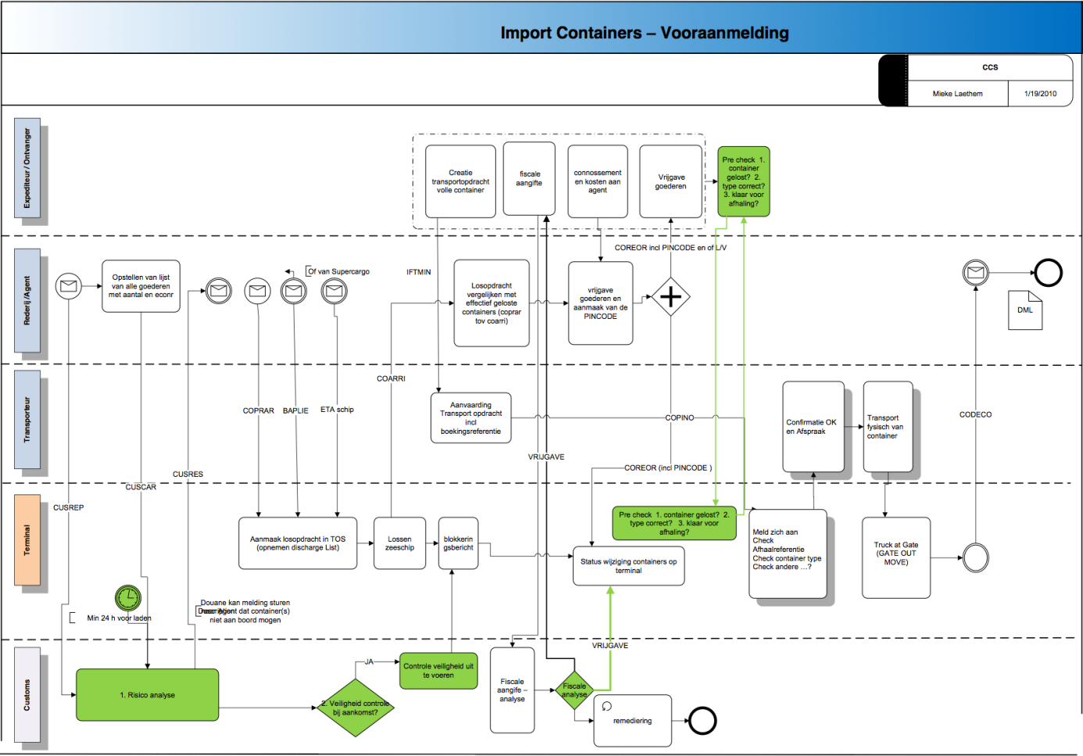

Figure Pre-announcement

The following diagram shows how the data generated in this business process can be utilized to execute and continually reschedule the sub-chain, from the vessel arriving to the departure of the inland transportation to the inland terminal.

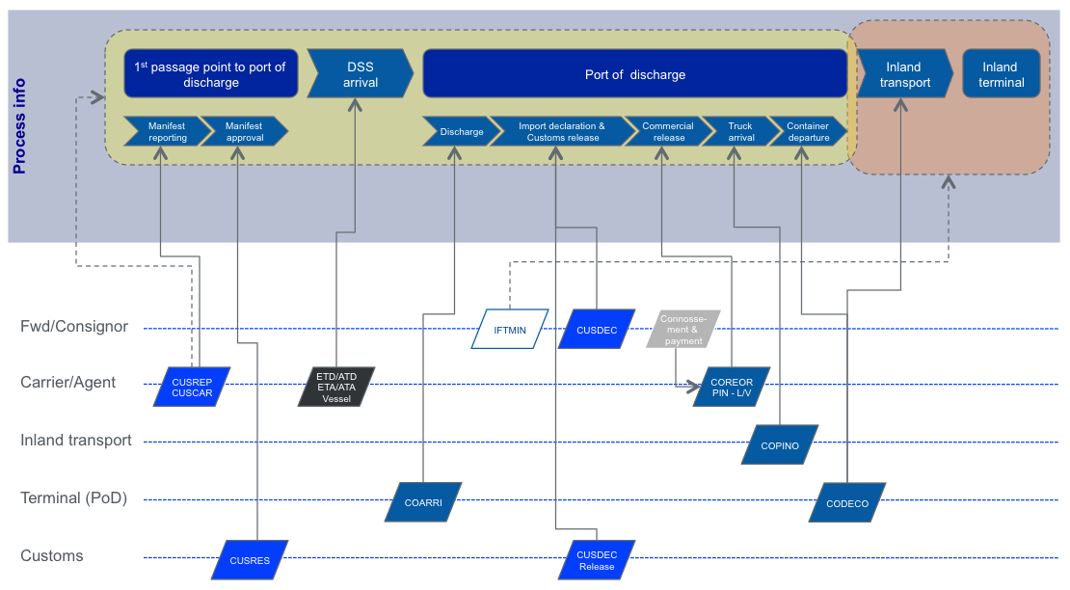

Figure Efficient sea/hinterland interfaces

The importance of this process is that it can be applied to a large category of international shipments. No specific information is required from the shipper or freight forwarder: The sea and hinterland legs are aligned based purely on information that is available within the seaport. The benefits achieved are among the most crucial in the end-to-end supply chain.

The process can be extended upfront (towards the port of loading) by using the ICS information as starting point instead of the import manifest (CUSCAR).

The Flemish pilot addresses elements of this scenario, incorporating import clearance activities by customs brokers as an integrated part of the co-modal transport chain.

### Secure Trade Lanes

This scenario finds its origin in the interoperability concept agreed between Smart-CM and Integrity. It shows the interaction between CSD devices, Integrity’s open SICIS system, the so-called Smart-CM neutral layer, and value added services of Integrity and Smart-CM, respectively; see Figure 19.



Figure Common INTEGRITY and Smart_CM demonstrator

Both INTEGRITY and Smart-CM aim at significant improvements in global door-to-door container transport chains visibility. The projects, however, use different approaches. Despite this, there is close cooperation between INTEGRITY and Smart_CM and the intention is to ensure interoperability between the systems developed in the two projects[27]. To verify this interoperability, joint demonstration activities have been initiated. Technically, interfaces are developed by implementing web service calls between INTEGRITY's SICIS system and the Smart-CM neutral layer, enabling both systems to exchange information on container shipments provided by Container Security Devices (CSDs), thus making it possible to track container shipments based on combined information delivered by both systems.

The interoperability of both systems will be validated in joint demonstration activities, including international trade lanes which exceed the coverage of one of the projects alone. It will be proven that the combination of the information delivered by both systems will nevertheless ensure reliable tracking of the complete trade lanes.

Figure 20 shows how the data generated in this business process can be utilized to execute and monitor the end-to-end chain, from the closing and sealing of the container until the deactivation of the CSD at the point of delivery.

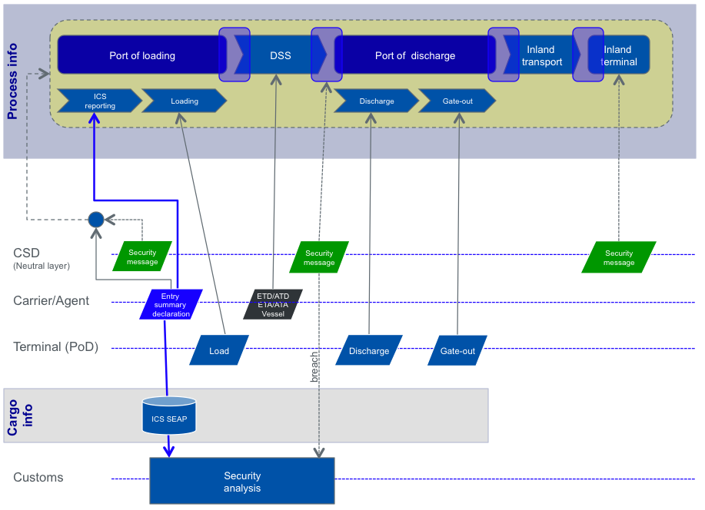

Figure Customs’ security analysis as part of the logistics process

Figure 20 also shows that customs processes are an important part of an integrated set-up, and decision taken by customs influence the progress of the logistics process.

For the Smart_CM approach we need to be aware that this end-to-end transport chain represents a limited class of international shipments, due to the utilization of CSD devices. INTEGRITY goes a different way: the use of CSDs is included (since the data provided by them cannot be achieved in the same quality by different means) but the INTEGRITY approach is not dependent on them since it cannot be expected that a significant number of containers will be equipped with CSDs in the near future[28].

### Co-modality in Logistics Planning and Execution

This scenario finds its origin in the generic intermodal planning process defined within FREIGHTWISE that is being demonstrated in real-life cases in the DiSCwise project. Figure 21 shows how data that are relevant for co-modal planning and execution purposes are being exchanged between clients and providers of so-called Transport Services.

Providers of transport services are able to electronically publish their service offering using the Transport Service Description (TSD). These could be services to connect the port of discharge to the hinterland. The forwarder responsible for organizing the transport to the hinterland can plan this hinterland operation – either as a single road leg, or as a co-modal transport chain that exists of multiple legs combining rail or barge with road for the ‘last mile’. After planning the forwarder communicates the booking and transport instruction data to the operators using the Transport Execution Plan (TEP). The latter are able to report back on the status of the transport execution using the Transport Execution Status (TES). Based on feedback received from the individual legs, the forwarder is able to monitor the status of the transport chain up to the point of delivery. In case of deviations he might be forced to re-plan the hinterland transportation.

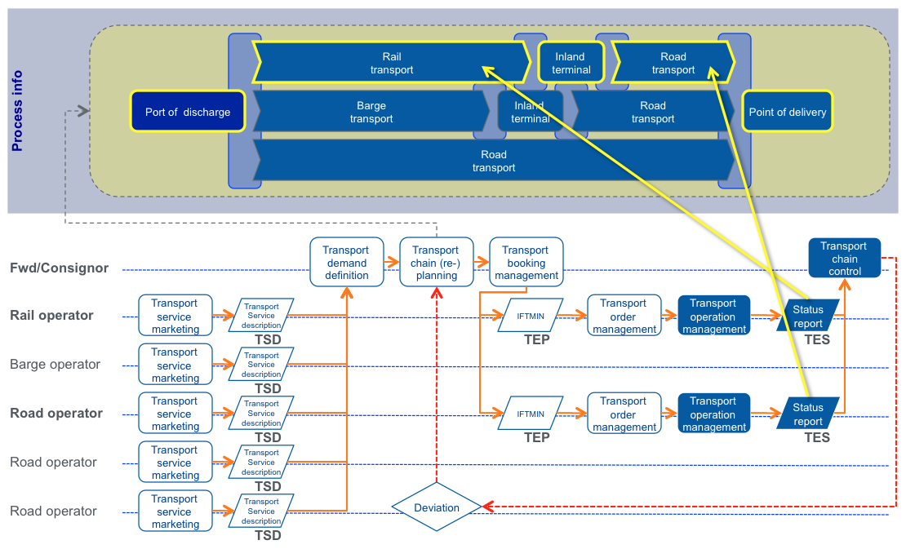

Figure Co-modal transportation into the hinterland

Note that the example scenario described above starts from the port of discharge and ends at the point of delivery, which is the consignee. However this approach can be followed for any point-to-point[29] transport chain that includes multiple modes of transportation. It can be door-to-door, terminal-to-terminal, terminal-to-hinterland, etc. In this case we used an example from the port of discharge, as this enables us to show the integration with the other scenarios.

## Integrated Process Description

We can now conclude on the full scenario. This scenario integrates these thee approaches into an integrated process scenario. This scenario supports efficient sea/hinterland interfaces and secure trade lanes processes described above (both of which are strongly focussed on the execution phase). It also adopts the Freightwise approach for handling an end-to-end shipment as a transport chain in which the individual segments are composed of Transport Services. Each of these transport services can be published (using TSD), contracted (using TEP) and monitored (using TES). The transport planning phase is integrated for the transportation from port of discharge to point of delivery in the hinterland. This enables us to demonstrate end to end transport chains from start to end, whereby there is more flexibility on the exact hinterland operations finally chosen to reach the final destination. By integrating the information from the various legs (services) we create optimal visibility, alignment between subsequent legs, pro-active rescheduling and personalized event management.

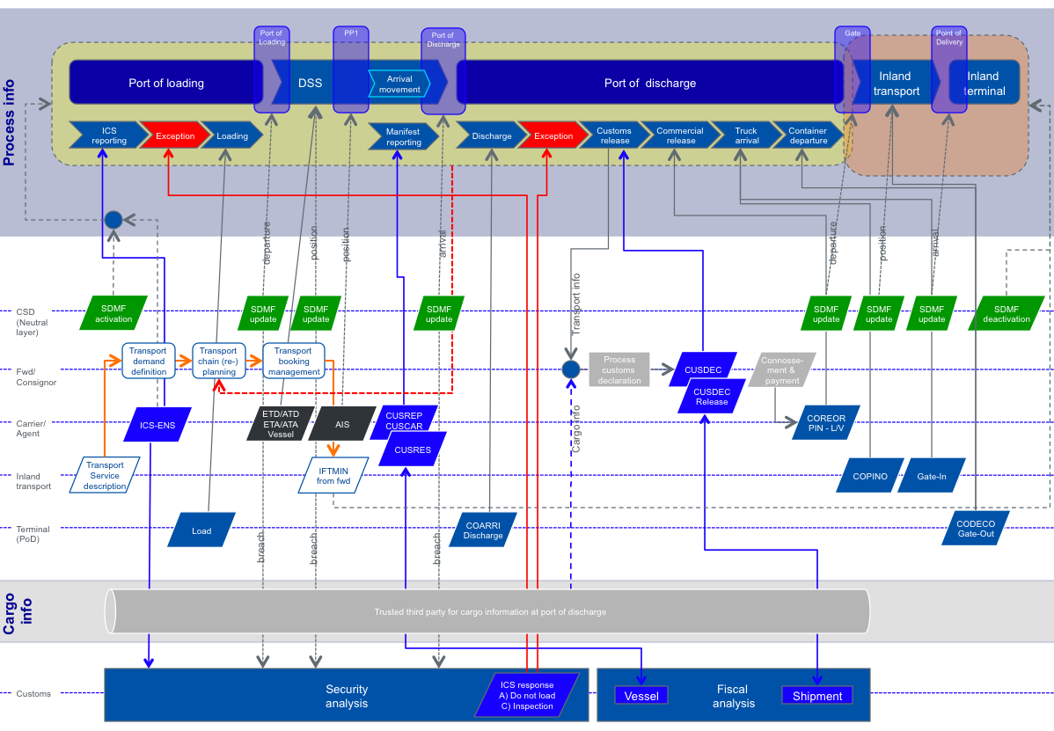

Figure : Integrated process scenario

The scenario consists of the following elements (note that not all steps are always executed in that strict order):

1.     The container is being closed and sealed at the shipper or consolidation center, and the CSD attached is being activated. This results in a container trip being created. During the container trip the CSD device enables monitoring of the individual container up to its deactivation at the point of delivery, using the Security Data Message (**SDM**).

2.     The cargo content of the container is pre-announced through the ICS entry summary declaration that should be provided 24 hours before loading the container. All such official reporting to transport regulators can take place using the Common Regulatory Schema (**CRS**) message. This facilitates the security risk assessment by the customs authorities in the port of discharge, which may also use possible container breaches that may occur. This risk assessment may lead to the container not being loaded into the vessel or to the requirement to inspect the container in the port of discharge.

3.     The movement between port of loading and port of discharge can be monitored by the loading and discharge reports and by the shipping line providing updated ETA information. The Transport Execution Status (**TES**) message is used for reporting by individual logistics services providers. In case the container is being transshipped, the CSD can indicate container specific positioning information, using the Security Data Message (**SDM**).

4.     Based on expected arrival time to the port of discharge, using Transport Execution Status (**TES**), as well as on the available capacities (and pricing) of hinterland operations at that time as published by the Transport Service Descriptions (**TSD**), the forwarder can plan the best hinterland transport chain – using also rail and/or barge services – from the operators that he normally prefers to work with.

5.     Upon arriving to the port of discharge, the arrival movement and the import manifest is conveyed to the port or customs authority, using the Common Regulatory Schema (**CRS**) message.

6.     In order to be transported as soon as possible to the hinterland, monitoring takes place of physical activities to be completed (discharge, inspections) as well as ‘green light’ information (customs release, commercial release). For the customs release it is necessary to complete an import or transit declaration or to agree on a trade facilitation regime. The Transport Execution Status (**TES**) can be used by customs brokers to provide feedback to forwarders on the clearance status.

7.     Aggregated process information may lead to replanning and rebooking of the hinterland transport chain in order to mitigate the impact on the end delivery time and still comply to required arrival time by the customer. The Transport Execution Plan (**TEP**) can be used for rebooking.

8.     The sea part and the hinterland part of the end-to-end transport chain are linked to each other as early as possible in order to provide sea terminal and hinterland operator reliable advance information as to where, how and when the cargo is being routed inland.

9.     Hinterland operators can pre-announce their intention to pick-up a container and can also monitor the availability of the container for hinterland transport – this allows for better interfacing between sea and hinterland leg. Again, the Transport Execution Status (**TES**) can be used for reporting the pre-announcement.

10.  The container leaves the gate with the hinterland operator and is being transported to the point of delivery where the CSD is deactivated, as reported by the Security Data Message (**SDM**), and the container trip is finalized.

In the end the consignee benefits from a delivery which has minimal lead time, costs or carbon footprint, and which has improved reliability which allows him to reduce safety stocks and working capital.

Fit Between the Integrated Scenario and the Common Framework

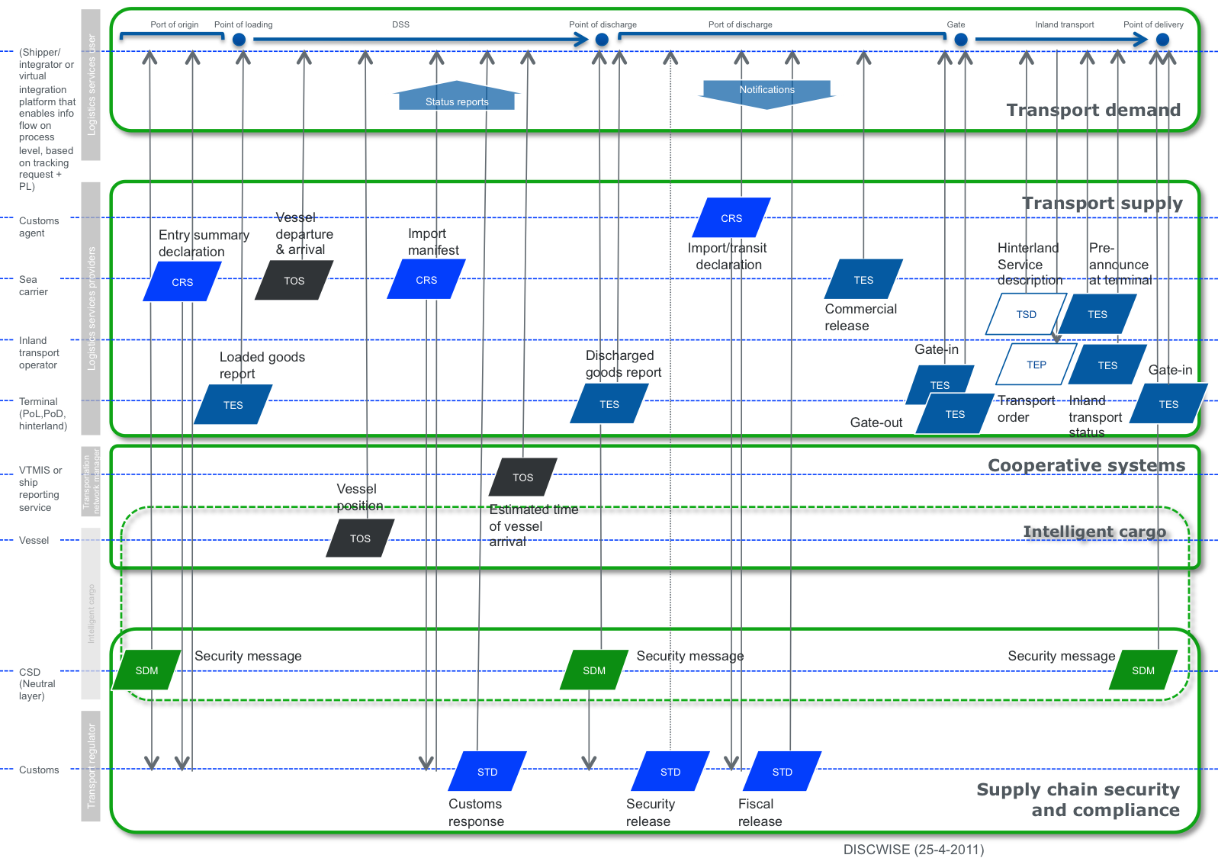

Figure 23 shows how the integrated scenario fits into the common framework. Primarily this concerns the mapping of the process to the functional domains in the figure ‘Common Framework summary’.



Figure Integrated scenario vs the Common Framework

Next section will go into more detail as to the common framework standards used for interoperability.

## Interoperability of Systems

In this section we show how ICT systems are being used that have originated from past projects (Smart-CM, INTEGRITY, FREIGHTWISE) and how the Common Framework ensures interoperability between these and commercial systems; see Figure 24. For the purpose of the latter we are referring to data exchange standards that have been introduced in Smart-CM and FREIGHTWISE and which are being integrated in the common framework.

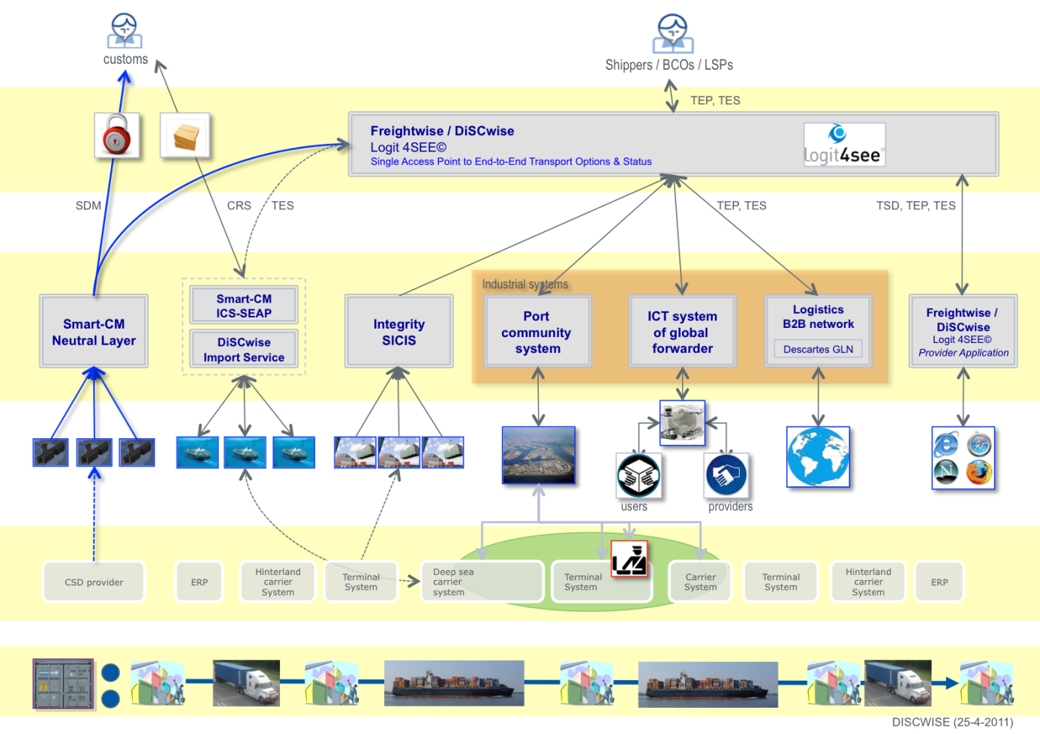

Figure Interoperability of EC projects and commercial systems

### Use of systems and standards from previous projects

#### From Smart_CM

Systems used are:

* The Smart-CM neutral layer is used to provide a single window to container security information;
* The ICS-SEAP commercial platform is used to provide carriers and forwarders a single window for lodging ICS ENS information, even if they need to report to multiple member states;

The SDMF (Security Data Message Format) is used but will be mapped to the TES (Transport Execution Status) format in order to harmonize all sorts of status reports concerning the load unit and the service transporting/handling it.

#### From INTEGRITY

System used is the SICIS platform, which provides

* A consolidated view on container terminal status messages, CSD information and AIS vessel tracking data for means of container tracking;
* CSD alert messages for means of container security;
* Consignment information provided by the shipper for means of Customs’ risk assessment

#### From FREIGHTWISE

Systems used are:

* The Logit D2D platform is a transport process management engine that provides planning and visibility functionalities for end-to-end transport chains;
* The Logit D2D user application provides planning and visibility functionality for the end-to-end intermodal transport chain;
* The Logit D2D provider application provides individual logistics services providers the possibility to publish services, accept bookings and reports status for individual legs in the chain;

The Logit D2D prototype was developed in the D2D and FREIGHTWISE projects. Logit 4SEE® is a commercial product[30] based on the Logit D2D prototype, and the change of name reflects a more integrated offering but also addresses branding issues. As part of DiSCwise, Logit 4SEE® is implementing new features in order to be able to execute the pilots and comply to the Common Framework.

The FREIGHTWISE TSD (Transport Service Description), TEP (Transport Execution Plan), TES (Transport Execution Status) and TOS (Transport Operation Status) formats will be used in order to harmonize the information flows concerning service publishing, booking and status reporting concerning the load unit, the service transporting/handling it, and the transport means moving it.

In order to enable legacy systems and commercial products to communicate according to these message formats, convertors need to be deployed. This is the topic of the next section.

### Connectors

Figure 24 and Figure 25 shows how FREIGHTWISE standards are being used as a generic data exchange standard. This is needed since the integrated scenario already shows that multiple UN/CEFACT dialects are being used, which cover the IFT* and the CO* and Customs specific message sets. This demonstrates the diversity of current messages and the need for a Common Framework.

In order to do so we will make use of connectors that translate a variety of message types that are part of existing standards to the messages within the Common Framework. Such connectors will make use of the ontological approach in the e-Freight project through which a systematic mapping onto the Common Framework message formats can be defined and executed.

We envision that connectors will be provided by commercial software vendors that include such connectors in their product portfolio. Moreover past and future EC project may implement specific connectors in order to facilitate integration in a particular business case demonstration. E.g. a connector towards INTTRA was deployed in the Freightwise project. Within DiSCwise connectors will be implemented in order to facilitate the pilots. One example is that Logit 4SEE® will be connected to the Descartes Global Logistics Network (GLN), specifically for transport order information (using the **TEP**) and status reporting (using the **TES**).

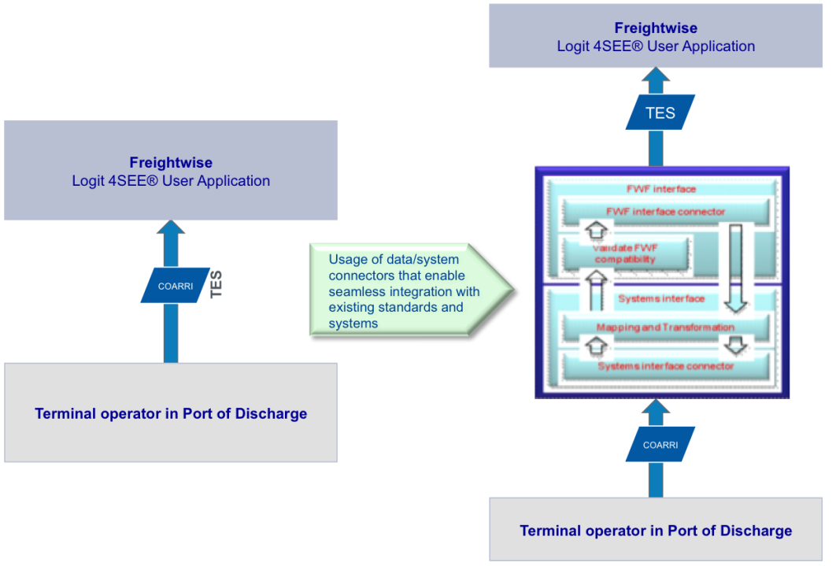

Figure Linking terminal systems and the Logit 4SEE™ User Application using a connector

### Intelligent Cargo

In the above described scenario, the aspect of intelligent cargo will be demonstrated through the use of container security devices (CSDs). The Euridice framework will be deployed as to how the CSD communicate with the other systems and applications in the demonstration scenario.

Beyond this state of the art scenario, an evolution scenario can be hypothesized where Intelligent Cargo will have higher impact by reducing manual operations and supporting more detailed monitoring and real-time event management. This visionary scenario relies on pre-requisites that will be accomplished towards 2020, as forecasted in the European Commission Impact Assessment study on Intelligent Cargo[31].

In Figure 26, we have highlighted the changes on the operational scenario and the corresponding benefits that might result from full realization of EURIDICE’s Intelligent Cargo concept. We have also indicated the pre-requisites that have to be met, on systems, platforms and organizations, to make these changes possible.

Our considerations are based on the EURIDICE pilot being carried out at the Port of Trieste, that involves forwarders, agents and customs in a scenario very similar to the one proposed in this paper[32].



Figure Euridice impact on operational scenario

A further important change expected with Intelligent Cargo is to allow extension of the scenario even in those cases where the value of transferred goods does not justify the adoption of state-of-the-art active security technologies.

For example the above-described actions, with the exception of real-time monitoring during sea transport, could be implemented without active CSDs and a satellite-based security platform. Adopting the EURIDICE’s Intelligent Cargo architecture, less expensive tags could be deployed on containers and on contained load units to collect and store relevant cargo and status information. The use of active and always connected tags is not mandatory at all levels in the hierarchy of load units. A less costly implementation might use communication and computing power available when the container gets in range with active devices, e.g., at terminals or on connected vehicles, to update and trigger the Intelligent Cargo agents.

Of course, this approach requires a shared, open and trusted platform allowing IC units to interoperate and to interact with fixed and handheld sensors, and that these are available along the route to provide the necessary cargo connectivity infrastructure. These are necessary pre-conditions for fulfilment of the EURIDICE vision, relying on the diffusion of Intelligent Cargo devices and the adoption of common platforms in the next years.

Therefore, rather than contributing specific technologies and standards, EURIDICE proposes an alternative way to implement the scenario, positioned forward in the future when cargo tags and devices will be widespread, interoperable and connected through an adequate platform.

# Using the Common Framework to implement end-to-end services

The Common Framework supports (1) **standardized data exchange** between individual roles in the co-modal transport & logistics process. On top of that, the software components demonstrated in the DiSCwise pilots show how logistics services clients and providers can participate in that process through the use of (2) **lightweight and efficient web-based applications**. This enables SMEs to participate, even if they have not implemented internal ICT systems with interfaces that are compliant to the Common Framework.

However, this still leaves the problem of combining multiple transport services into end-to-end transport options. A true interoperable marketplace between logistics services clients and providers requires that clients are able to use (3) **end-to-end transport options** as opposed to individual services, but with the same ease-of-use. Moreover the (4) **connection to proprietary systems** should be simplified and made more efficient. This chapter further investigates these last two issues.

## Simplifying the use of end-to-end transport options

[33]There is a need for increased collaboration between transport chain actors, e.g. shippers, freight forwarders, transport operators and terminal operators, in order to achieve efficient, and adaptive intermodal transport chains. By a transport chain we refer to the activities and organizations that are involved in handling and moving products from a producer depot to a customer depot in a transportation network. The proposed approach, called *Plug and Play Transport Chain Management* (PnP TCM)[34], focuses on collaboration for developing transport solutions, for activity coordination, and for administrative information transactions.

PnP TCM is based on the Common Framework whose main purpose is to simplify the phases of planning, executing and following up transport services between the clients of such services and the providers of such services. An important aim is to be able to do this without interfering with the internal processes and systems in the organisations. The main means to achieve this is by providing a small set of well-defined *information packages* for which the responsibilities and the requirements for use are specified. The Common Framework identifies four roles in a transport chain. A *Logistics Services Client* is anyone that needs to have cargo transported (which could be a 3PL). A *Logistics Services Provider* carries out the transport of the cargo, including the management of the transport services and the operation of the transport means and handling equipment. The *Transportation Network Manager* is responsible for providing information regarding the infrastructure related to planning and executing transports. Finally, the *Transport Regulator* monitors that all transport services are completed according to existing regulations. All interaction between these actors makes use of the information packages.

The PnP TCM approach can be seen as an instantiation of the more general *Plug and Play Business* concept[35] and aims to:

* making information about the available transport services easily accessible,
* providing support for finding the “best” set of transport services for a particular transport, including a match-making functionality that makes it easier for potential transport chain actors to find each other and negotiate with potential collaborators,
* supporting the negotiation and collaboration between the actors in a transport chain,
* lower the entry barriers for small-sized companies to participate in highly integrated transport chains by providing low cost and easy-to-use software tools.

Ideally, it should be implemented in a completely distributed fashion, both with respect to control and information, and it should be seamlessly interoperable with relevant legacy ERP (Enterprise Resource Planning) systems of the participating actors.

n the PnP TCM concept, transport chains are viewed as *virtual enterprises*, which may be defined as temporary alliances of enterprises that come together to share skills or core competencies and resources in order to better respond to business opportunities, and whose cooperation is supported by computer networks[36]. Another important concept for the PnP TCM concept is *Internet community*. Potential transport chain actors join this community by executing the Logit 4SEE™ software. To enter the community, an actor needs to declare its address and other formalities, as well as, agreeing on a user license agreement. In addition, a TSP needs to provide a Transport Service Description (TSD) for each transport services it provides. The TSDs should be updated continuously so as to mirror the current situation. The community is dynamic in the sense that enterprises may join and leave it at any time. It can be seen as a *breeding environment* for transport chains, i.e., an association of enterprises that have both the potential and the ambition to collaborate with each other through the establishment of long-term cooperation agreements and an interoperable infrastructure. As the figure below exhibits, such chains can become quite complex, and support measures are required to enable SMEs using them.

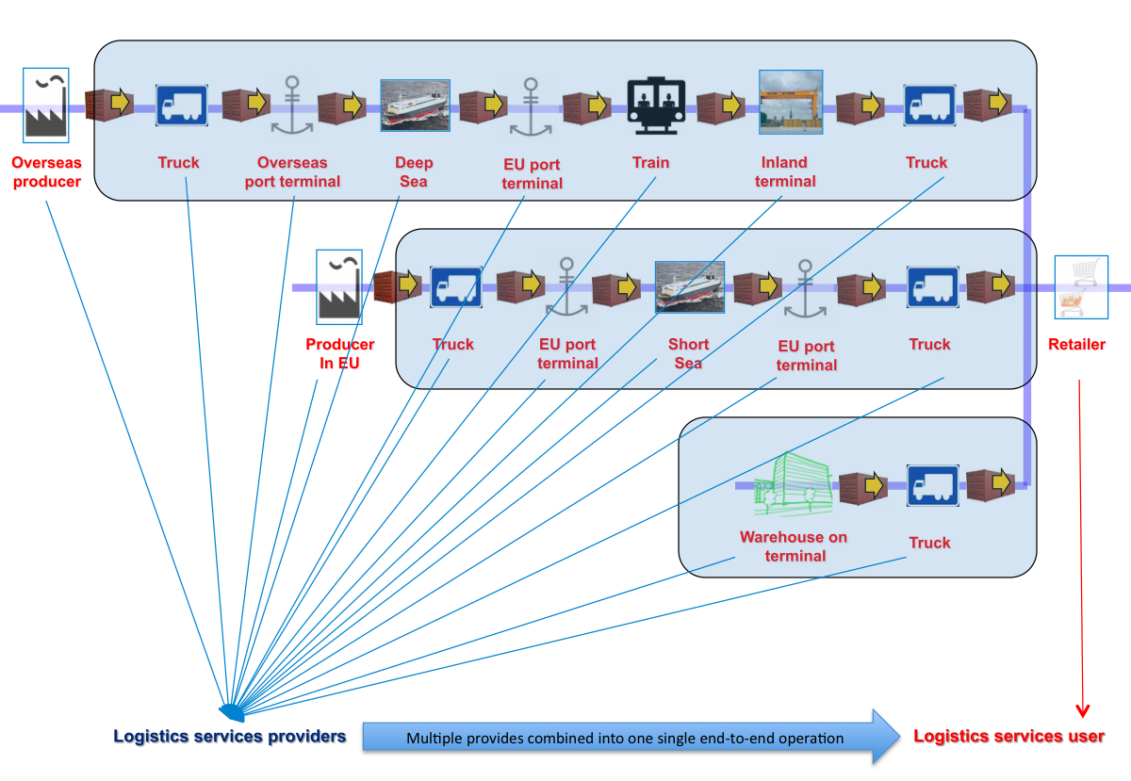

Figure 27: An illustration of the complexity faced by a user of co-modal transport & logistics services

## Simplifying the connection to proprietary systems

The figure below illustrates the Common Framework approach where each actor uses software components to set up and participate in a transport chain.

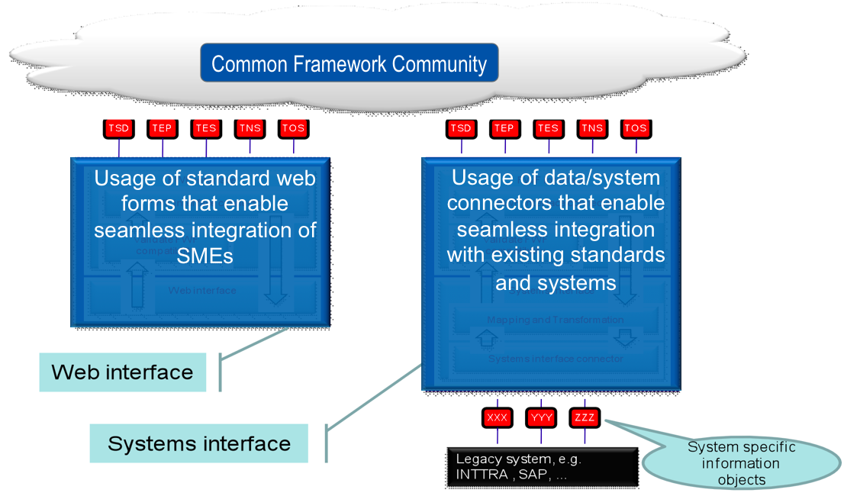

Figure 28: Interaction with existing actors and systems

For actors to participate in the Common Framework community, two approaches can be followed:

1. Using proprietary/legacy or commercial systems to interact directly with other information systems in the community. It uses so-called ‘connectors’ for translating existing formats used by proprietary systems (often de-facto standards) and less generic (often mode specific) standards. By deploying connectors from these proprietary systems to the Common Framework, an explosion in the number of alternative connectors between systems can be avoided (since the Common Framework is used as a ‘neutral’ format) and a sufficiently large customer based for each connector can develop. We foresee a lively marketplace to implement and market such connectors. It is seen as the main mechanism to break through the vested interests of ‘large system’ suppliers. It allows communities to exchange data, whether they are using these ‘large systems’ or not. These ‘connectors’ are software components that will be provided by SW vendors.
2. Using a simple web browser interface to interact directly with other information systems in the community, which may be particularly useful for small enterprises. It allows SMEs to communicate with Common Framework standards even though no specific measures have been taken to adapt their internal ICT systems (if available at all). These ‘web browser interfaces’ are software components that will be provided by SW vendors. Such ‘web browser interfaces’ should be provided at low costs, in order to hinder take-up by SMEs. Logit 4SEE® is an example.

For deployment of the Common Framework to SMEs, it is a requirement that connectors (1) and web browser interfaces (2) are made available at a sustainable cost level.

# Proposed Actions

## Introduction

In order for the Common Framework to be complete and accepted, a number of actions are required.

## Linking Systems Developed in EU Projects

The projects FREIGHTWISE, e-Freight, Rising and DiSCwise are related due to the fact that some consortium partners participate in all projects and that the same application is used to validate and demonstrate the project results. The focus in all these projects is door-to-door freight transport management.

SMARTFREIGHT concentrated on integrating traffic information and transport management information in order to make urban freight transport more efficient.

INTEGRITY and Smart_CM deal with security and compliance and value-added services using information from safety seals on containers for logistics purposes.

Euridice develops “middleware” that supports the use of “intelligent cargo”.

Examples and presentations are being used to show how the results of these projects could be interacting in practical supply chains. However, it would be highly beneficial if the project results could be implemented in a real “business case”, so that the results and the Common Framework could be demonstrated in practice. DiSCwise is demonstrating such practical implementation in its pilots.

## GS1 Cooperation

The TSD, TEP, GII, TES, and TOS messages form the basis for information exchange in the e-Freight project. As these messages are exposed to the e-freight business cases, and to the business cases offered by the GS1 members in the e-Freight GS1 cooperation, these messages will be enhanced.

It is proposed to closely monitor these business cases and provide change proposals to the Common Framework messages, if required. This is being done by the e-Freight project. It is not perceived at the moment that any of these will be fundamentally revised, but minor modifications will, most likely, take place.

## CEN and UN/CEFACT Cooperation

Further cooperation with CEN and UN/CEFACT needs to be established. As part of DiSCwise, a review of UN CEFACT TBG3 will take place and detailed change proposals to the Common Framework will be formulated. UBL cooperation is to be continued.

## Harmonisation with the WCO Data Model

In the area of Supply Chain Security and Compliance, work performed by the World Customs Organisation (WCO) seems relevant. Some form of harmonisation with the WCO data model seems relevant. As part of DiSCwise, a review of the WCO data model will take place and detailed change proposals to the Common Framework will be formulated.

## Complementing PEPPOL

The PEPPOL project (see Section 17.2) deals with ordering and invoicing in the area of public procurement. The Common Framework should be demonstrated to show that it may be used to “close the loop” and manage the transport of goods purchased using the PEPPOL mechanisms. As part of DiSCwise, a review of PEPPOL will take place and detailed change proposals to the Common Framework will be formulated.

## Extra Dissemination

Further contacts need to be established with FIATA (international association of freight forwarders) and CLECAT (its European counterpart), ESC (European shippers' council), and ELA (European logistics association).

## Electronic Waybill

During the ITS Congress in Stockholm in September 2009, the state secretary for transport in Sweden said as follows: “Future of transport – a multimodal challenge… the introduction of the digital waybill will be a revolution similarly to the introduction of containers in shipping in the 1950-ies”.

It is worth verifying if the information that has been included in this Common Framework is sufficient for defining the content part of an “electronic waybill” or an electronic contract for Origin to Destination co-modal transport. If so, then the legal issues should also be investigated. The so-called Rotterdam Rules do not satisfy the requirements for what in Sweden was called the “electronic waybill”.

The aim is to achieve a unified single transport document (**STD**) that can be used for all modes of transportation.

# Appendix 1: Relevant EU Projects

## FREIGHTWISE

FREIGHTWISE[37] was an EU funded project under the 6th Framework Programme (6th FP) for research and development that was completed in April 2010. FREIGHTWISE built on (and contributed to) ARKTRANS, developing a simple, standard framework for information exchange in co-modal transport that may be implemented at a very low cost.

## e-Freight

The e-Freight project may be considered a continuation of FREIGHTWISE and will provide an e-Freight platform supporting the design, development, deployment and maintenance of e-Freight Solutions which will be validated in business cases and pilots involving representatives from all relevant stakeholders in surface transport including large and small businesses and authorities. e-Freight deals with Framework, Single transport Document and Single Window.

Both e-Freight and DiSCwise projects provide a *holistic* perspective, integrating the various initiatives into the Common Framework.

## INTEGRITY

INTEGRITY[38] is a project intending to significantly improve the reliability, predictability and security of door-to-door container chains.

The kernel of the project is the development of the open so-called Shared Intermodal Container Information System (SICIS) allowing authorised companies and authorities to access planning and status information of selected transports. A framework is required to facilitate interaction between the SICIS and the stakeholders.

## Smart-CM

Smart-CM[39] aims to make trade and transport more efficient, secure, visible and competitive across the world in a global intermodal context, working along with existing initiatives such as that of AEO and the Green Lanes implementation.

Smart-CM will provide a simple - transparent - neutral - easy to handle solution for the interaction between public administrations (primarily customs) and the market players involved in the container transport chain management and administration business.

The interaction mentioned in the previous paragraph will require a framework for interaction and interoperability.

## SMARTFREIGHT

The SMARTFREIGHT project wants to make urban freight transport more efficient, environmentally friendly and safe by answering to challenges related to traffic management, freight distribution management, and a better coordination between the two.

The main aim of SMARTFREIGHT is therefore to specify, implement and evaluate Information and Communication Technology (ICT) solutions that integrate urban traffic management systems with the management of freight and logistics in urban areas. The actual transport operations carried out by the freight distribution vehicles will be controlled and supported by means of wireless communication infrastructure and on-board and on-cargo equipment.

## EURIDICE

EURIDICE is an Integrated Project funded under FP7 by DG INFSO ICT for Transport Area. The central concept of EURIDICE is the Intelligent Cargo[40], defined by its basic capabilities to self-identify, to detect the surrounding context, and to provide and use information services whenever required along the transport chain. To implement these capabilities EURIDICE combines radio-frequency identification (RFID), sensors networks, near-field processing units, all combined in a fixed and mobile web services infrastructure, to facilitate direct interaction between cargo items (individual packages) and between cargo items, load units (pallets, containers etc.), vehicles, and infrastructure.

In the EURIDICE vision, Intelligent Cargo connects itself to logistics services providers, industrial users and authorities to exchange transport-related information and perform specific services whenever required along the transport chain. This will produce significant benefits for the logistics industry and for the community, in terms of: enhanced and widespread capability to monitor, trace and safely handle moving goods; increased efficiency of freight transportation networks; improved sustainability of logistic systems.

## RISING

RISING[41] is a 7th FP project aiming at improving the competitiveness of door-to-door transport chains involving inland waterway transport and utilising River Information Services to achieve this. RISING builds on the results of FREIGHTWISE.

## DiSCwise

DG Enterprise has commissioned a study aiming at “assisting SMEs to participate in global digital supply chains in the transport and logistics sectors in the single market by (…) providing standard architectures”.

As mentioned above, both e-Freight and DiSCwise projects provide a *holistic* perspective, integrating the various initiatives into the Common Framework. In that context, DiSCwise is paying particular attention to SMEs and how they can take part in a digital supply chain. Moreover, DiSCwise aims to bridge the gap to real-life implementations and to push towards critical mass implementation. The DiSCwise pilots should demonstrate and pave the way for easy, affordable ICT adoption to increase the efficiency of the sector.

## EasyWay

EasyWay is a project under the EU TEN-T budget where 21 European member States, through their road operators as partners, cooperate on the establishment of Core European Services for European travellers and hauliers. The project shall be seen as the member states response to the requirements of the EU ITS Action Plan. Services are mainly relating to road traffic and transport, but include interfaces to other modes and the exchange of information at modal shift points. A specific area within EasyWay is dedicated to Freight and Logistics services.

## SuperGreen

A new EU project entitled “Supporting EU’s Freight Transport Logistics Action Plan on Green Corridors Issues” (abbreviated name “SuperGreen”) was started on Jan. 15, 2010. The 3-year project is a Coordinated Action supported by the European Commission (DG-TREN) in the context of the 7th Framework Programme. The purpose of the project is to promote the development of European freight logistics in an environmentally friendly manner. Environmental factors play an increasing role in all transport modes, and holistic approaches are needed to identify ‘win-win’ solutions.

## BeLogic

This project started in 2008, developing benchmarking and KPI concepts and solutions. Its results can be used to establish performance measurement mechanisms for co-modal logistics chains.

# Appendix 2: Results form INTEGRITY and Smart_CM

## INTEGRITY

### INTEGRITY – Intermodal Global Door-to-door Container Supply Chain Visibility

The INTEGRITY project aims at significant improvements of the reliability and predictability of global door-to-door container transports by optimizing the cooperation between transport industry and Customs Authorities in the China-EU trade corridor. The consolidation of data will significantly improve the transparency of the transport chain. At the same time the container security will be significantly improved, for example by providing access to reliable sources of consignment information.

The core of the project is the development of the open Shared Intermodal Container Information System (SICIS) allowing authorised companies and authorities to access planning and status information of selected consignments. The challenge of SICIS is the combination of existing technologies and new business processes together with legal and administrative agreements. Proactive planning according to the SCEM (Supply Chain Event Management) approach allows problems to be forecast well before they might occur. Matching logistics data with security information, including data from electronic seals, container security devices, and scanning equipment, together with the integration of the AEO (Authorised Economic Operator) concept, are basic measures.

Customs and shippers/3PLs are satisfied in one integrated approach. Several recent investigations show that the enhancement of Supply Chain Visibility provides significant benefits for all participants in the chain – both industry and Customs – this was already validated during the project.

The INTEGRITY project is funded by the European Commission in the 7th Framework Programme for Research & Development and liaises with several EU Directorates.

### SICIS – An open IT platform providing Supply Chain Visibility

In September 2009 – after a duration of the INTEGRITY project of one year - the open IT platform SICIS started to track containers along the entire logistics chain by consolidating all relevant data and related events which are generated during the transport. Since then SICIS regularly monitors containers during their door-to-door transport from China to Europe. As of October 2010, more than 1.600 containers were tracked by SICIS on their journey from China to Europe. This number will even increase by including additional trade lanes in the demonstration activities. As an example, interfaces to terminal operating systems were developed in order to feed terminal messages into the system. Another important feature is linking the container monitoring data with AIS vessel tracking information provided by satellites.

An important SICIS feature especially for Customs is the possibility to upload consignment data, which can be used by Customs to further optimize risk assessment processes.

SICIS is an open IT platform. It can easily be adapted to any trade lane world-wide. Due to its sophisticated interfacing possibilities, there are practically no limitations in data exchange with other systems or adoptions to the requirements of frameworks. Amongst others, interfaces to platforms like the EU projects Smart_CM dealing with different aspects of container visibility and CHINOS addressing the issue of RFID in container logistics were developed. Furthermore, data exchange with new cooperation partners like DP World was established, the latter being the second of the worldwide leading terminal operators implementing data exchange with SICIS in addition to project partner Hutchison.

Furthermore, SICIS is able to interact with any kind of Container Security Device (CSD). For this purpose, a standard CSD data interface was developed. Interfaces to CSD provider Savi Networks and China-based CIMC and Long Sun were established, negotiations with several further CSD providers are in progress; the principle is illustrated in Figure 29. INTEGRITY is the first project to achieve official approval by China Customs of the usage of CSDs.

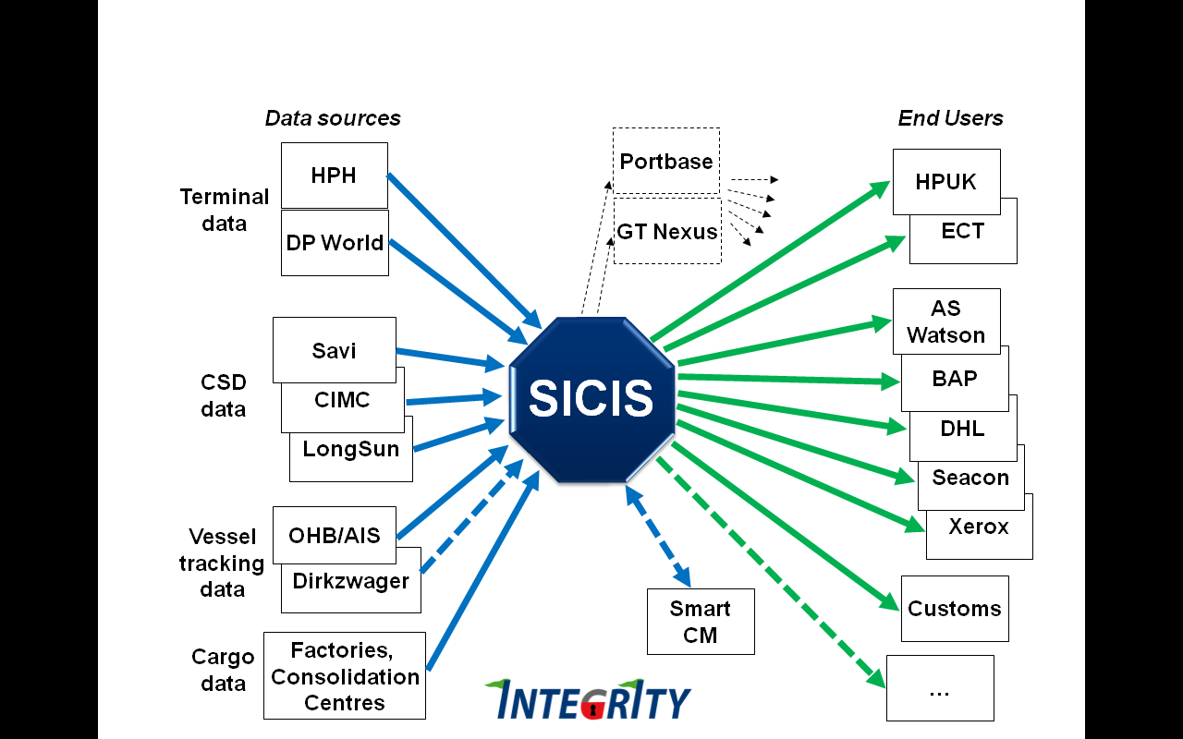

Figure The SICIS framework including project and cooperation partners

The first CSD equipped container started its trip from the DHL Consolidation Centre in Hong Kong in March 2010. After following the major INTEGRITY trade lane from China to Europe, the container was discharged at the Delta DDE Terminal of project partner ECT in Rotterdam in April and was unloaded at the DHL Global Forwarding Ocean Freight Warehouse in Rotterdam.

Since then SICIS tracks container movements by merging CSD data, terminal messages and AIS vessel tracking data on a regular basis. The vessels’ positions together with related events like course divergences are visualized on a world map.

In the past, the starting event in SICIS was still a manual process performed by the factory where the container was stuffed. With the use of CSDs this process is also automated. By closing the container, the CSD is activated. Immediately a GPS position is acquired and all details are transferred to the SICIS server. The GPS module and the GSM communication allow the reporting of waypoint events by using geo-fencing functionality. It also reports any tampering of the container. Possible gaps during the sea leg of the voyage are closed by integrating AIS signals of the vessel obtained via satellites.

However, it should be noted that, although the data quality provided by CSDs cannot be achieved by other means, the INTEGRITY approach is in no way de-pendent on CSD use. Equipping each and every container with a CSD in the near future is unlikely. Therefore, a manual start process and tracking based on terminal data only are still options, which already imply significant benefits.

## Smart_CM

The work performed within SMART-CM focuses on the development, demonstration and the after project robustness and operation of the “SMART-CM platform” which will support secured and non biased critical information exchange among actors of the global logistic chains (B2B) and between the logistics actors and the Customs authorities (B2C) for achieving quick customs clearance of the containers and better chain visibility and control by the logistics actors. Thus three main goals are envisaged:

**A. An “*Interoperable Single Window platform solution”****,* enabling all logistics actors and customs authorities to monitor the container security status independently of the Container Security Device (CSD) technology applied in a trade lane.

***B. “Neutral information administering organization”****,* managing the platform, guaranteeing data integrity along the whole process of security related container info gathering and provisioning information from the platform to the stakeholders.

***C. “Industry Added Value creation”*** on the basis of the information the technology and the trusted environment of a neutral platform enable to be made available in order to create direct business benefit. Thus the “burden” of the security regulation compliance may be transformed to an added value for the transport industry.

The architecture of the operational platform is depicted in Figure 30.



Figure The Smart_CM configuration

The neutral layer is a single window in the sense that it provides customs and logistics actors access to container security status information independent of the actual CSD provider used. It guarantees collection and distribution of

* neutral information: the common set of information provided by CSD devices that is required by customs to monitor the security status of the container. The SDMF message format is being developed for this neutral information.
* logistics information: be either information provided by CSD devices that is required by logistics actors and not included in neutral information as explained above, or it can be information provided by and required by logistics actors or customs.

The project issued a call to external CSD providers who would like to test their technologies. From the companies expressed their interests two have been selected for participating in real global demonstration corridor. Together with the project partner EDC (Belgium -EU), the new comers RAYTHON (USA) & CIMC (China) completed a good representation of the CSD technology providers around the globe contributing to project solutions development.

On the other hand, logistics VAS services of SMART-CM platform mainly deal with the monitor of the chain execution against initial plan and the provision of customised, by industrial actors, notifications and alerts on deviations. (Container ETA update/Container prior-to-arrival notification/Container delay alert generation/Container idle time alert at terminals/ Container geo-fencing alerts on regions/ E-mail notification alert handling for all VAS). Certain platform information exchange interfaces have been esteblished towards external systems:

* Vessel Tracker for AIS information,
* Load and unload events from Shipping lines own systems (COSCON)
* Updates of container ETA to 3PL (K+N CIEL system)
* Interface to terminal operators internal systems (*be implemented)

The ICS SEAP (as a ‘Customs VAS’) aims to provide one stop shop for entering and retrieving entry/exit summary declarations. Shipping lines will visit multiple ports within Europe and will be provided a mechanism to provide a single data entry to describe the goods to be discharged at individual ports. The platform ensures that entry summary declarations will be communicated to individual customs authorities, adapted to implementation guidelines issued by that authority.

Two Advanced Added Value Services, stimulating the research dimension of the project, are also specified and confirmed regarding their feasibility for full operation in the future. They will reach the level of a prototype development and validation through simulation within the project life cycle. Entitled “Strategic routing scenario planning” & “Dynamic intermodal (re)routing of containers” they guarantee that the SMART_CM work efficiently takes into account the state of the art technological research performed in other projects and could act in the future as new technology/solutions enabler.

Two phases of demonstration activities are already concluded. The first for actors’ familiarisation to the basic project technology and early validation of basic platform functionalities while the second for proving the full operation of the Interoperability Single window platform. The third phase of the demostrator will run from September 2010 up to February 2011, showing the full functionality of the complete platform and also providing proof for the interoperability with SICIS platform (developed within INTEGRITY project).

The demonstration corridors operated by the project partners DHL, K&N, COSCON involved major ports around the globe: Antwerp, Rotterdam, Singapore, Ningbo, Dubai, Nhava Sheva (India).

The results of the real world tests concluded already a concrete project outcome towards industry: *“List of Key per-formance indicators of CSDs for security”,* providing the minimum requirements the CSD technology providers should fulfil in order to meet the customs and industry actors expectations for container security.

Finally, the demonstration activities created the basis for direct interface between EU and non-EU customs involved in the corridors and enabled detailed discussions on the concept implementation. A minimum agreement list on mutual recognition was developed that will constitute the basis for the involvement of the non EU customs in the project demonstration & evaluation activities in the next project phase.

# Appendix 3: Standardisation

## Introduction

If the Common Framework shall be acceptable to industry and others, standardisation is an important issue. Efforts have already been made to start standardisation activities.

## GS1

GS1 is a global standards organisation built on membership. Recently GS1 has started activities for providing logistics interoperability in its logistics Forum. The Logistics Interoperability model was developed - essentially targeted to road transport. LIM is in the process of being implemented. However GS1 has recognised that a LIM version 2 is needed that covers all modes. Cooperation between the e-freight project and GS1 has been established with the intent to jointly develop LIM version 2.

## UBL/OASIS

Through cooperation with the US Department of Transport’s Freight Management Initiative, FREIGHTWISE representatives were introduced to the OASIS/UBL Transport Sub Committee. This contact resulted in a joint decision to adapt three of the FREIGHTWISE messages for UBL standardisation. These were TEP, TES, and TOS.

The cooperation is considered successful by all, and the TSD and GII are now in the process of being included in UBL version 2.1.

## CEN

Within CEN thee are two approaches to take. One is to have a so-called CEN workshop accepted, where the content of the workshop is perceived as a standard for a limited amount of time. The other alternative is a full standardisation process.

It may be of interest to apply both for the Common Framework.

A dialogue has been stared with representatives for CEN.

## UN/CEFACT

So far, cooperation with UN/CEFACT has been limited. It seems, however, that UN/CEFACT working group TBG3 has established a new integrated information model - not merely creating XML schemas from existing EDIFACT messages. This development needs to be investigated.

# Appendix 4: Terms of Reference

This section summarizes the input received from various EC DGs in a request to achieve better harmonization between efforts in the area of interoperability frameworks that were taking place in a number of projects.

Realising the ambition stated in Europe 2020 (see Section 18) and that the European Commission has supported related work with frameworks and overall architectures for information exchange in the transport and logistics sector for many years projects is , it was perceived that future investments in research, development and deployment in the area of transport and logistics management (use of information and communication technologies, ICT, in the area of transport and logistics) would benefit from building upon the same Common Framework.

This interoperable and coherent Common Framework, facilitating sharing and information exchange between all required stakeholders should be:

* Deployed to industry and public bodies in order to contribute to intelligent traffic management, better logistics, reduction of CO2 emissions in the road, aviation and maritime sectors, setting of common standards and developing the necessary infrastructure support, improving the efficiency in cross border sections and inter modal nodes, contributing to the effectiveness of the overall EU transport system, and facilitating that transport and logistics networks enable industry throughout the Union to have effective access to the Single Market and the international market beyond.
* Improving the effectiveness of transport and logistics related research by providing a Common Framework on which projects should build so that interoperability between systems developed, demonstrated and deployed would be improved and that duplication of efforts could be minimised.

Representatives for various EC DGs have participated in the discussions about the Common Framework for some time and asked in May 2010 that the following issues were analysed and concluded:

* What is the added value to the business community from combining the results of the projects into one common framework?
* What are the connections between the core projects (eFreight, FREIGHTWISE, DiSCwise, Smart-CM, INTEGRITY, EURIDICE and SMARTFREIGHT), and others that are related (SuperGreen, BeLogic, SUPPORT, CONTAIN, CASSANDRA, etc)?
* Which information, functions, processes, services, software, and hardware components do the projects cover and to what extent could these be "integrated" in a common framework?
* What business cases may be employed to demonstrate the benefit of One Common Framework? What evaluation criteria must be used? For which logistics flows is the use of the Common Framework profitable?
* Are there any specific infrastructure needs arising from this (if so, what are the possible sources of finance)?
* Will such a strategy result in services to stakeholders that require payments?
* How does “single windows” need to be defined and implemented to ensure that authorities and companies must provide information only once for border crossing transport and logistics operations?

The presentation of individual projects must be kept to an absolute minimum. Deliverables of individual projects (be it already existing or forthcoming) should rather be presented through a discussion of cross-cutting issues, such as supply chain visibility, security, logistics management etc;

* The paper must clearly present the information requirements that arise from the projects to stakeholders (terminal operators, shippers, carriers etc) and the services that are produced using this information;
* For technology specific projects, the paper needs to outline what technologies are to deployed and what the business cases would be for each of the technologies;
* The potential of sharing information across the projects must be discussed in depth;
* The policy section needs to be updated with the on-going iniatives (Europe 2020, new White Paper, ITS directive etc);
* On a general note, the structure and the contents of the paper should to a large degree determine the structure and content of the event in Bremen.

# Appendix 5: EU Policies

The policies that need to be addressed, or are in support of this action, include:

* The Mid-Term Review of the 2001 Transport White Paper[42] in which the expression “Co-modality” was introduced to signify optimal use of all modes of transport singly and in combination.
* The Freight Transport Logistics Action Plan launched by the European Commission, amongst a number of policy initiatives, to help Europe address its current and future challenges relies on co-modality and on advanced technology to ensure a competitive and freight transport system whilst promoting environmental sustainability. The Freight Logistics Action Plan focuses on quality and efficiency for the movement of goods, as well as on ensuring that freight-related information travels easily between modes. These objectives can be reached primarily through e-Freight[43] solutions aiding collaboration between all stakeholders involved in freight transport chains. Part of the action plan is establishing synergies with related policies such as e-Maritime
* The ITS Action Plan Oct 2008 “ITS tools constitute a core enabler for the management of such logistic chains, notably in maintaining a paperless information trail in the management of the physical flow of goods (e-Freight).” Resulting in a directive for ITS deployment.
* The e-Customs initiative introduced by Decision No 70/2008/CE.The e-customs vision for ‘electronic declarations as a rule’, interoperable national computer systems and single window solutions will facilitate information exchange on cargo movements. In the context of the European e-Customs and the Modernised Customs Code programme Single **Windows** are foreseen.
* Directive 2009/17/EC, in the framework of the Third Maritime Safety package, modifying Directive 2002/59/EC for establishing a Community vessel traffic monitoring and information system (the "VTM Directive"). One of the main objectives of the amended Directive is to guarantee that all Member States will be interconnected via the Community maritime information exchange system SafeSeaNet (SSN) in order to obtain a complete overview of the movements of ships and dangerous or polluting cargoes in European waters. The integrated maritime transport strategy opens new horizons for SSN as a core platform to support “upgraded EU maritime transport information management”.
* Communication and action plan with a view to establishing a European maritime transport space without barriers COM(2009) 10/2. Short term actions include ‘simplification of customs formalities for vessels only sailing between EU ports’ and ‘clarification of the use of IMO/FAL harmonised forms through a proposal to the European Parliament and the Council for a directive replacing Directive 2002/6/EC on reporting formalities for ships arriving in and/or departing from ports. Further the Commission is preparing measures for "National Single Windows" (systems that allows traders to lodge information with a single body to meet all import or export-related regulatory requirements).
* The development of the European Border Surveillance System (EUROSUR), which foresees the gradual creation of a common information sharing environment for the EU maritime domain. EUROSUR, focussing initially on the southern and eastern external borders of the EU, suggests to Member States a roadmap for gradually developing a common technical framework to support Member States' authorities in reaching full situational awareness over the coming years. EUROSUR is closely related to the ‘integration of maritime surveillance activities’ as described in the Commission documents COM 2009-538 ‘Towards the integration of maritime surveillance: **a** common information sharing environment for the EU maritime domain” and SEC 2009-134.
* The e-Maritime aimed at fostering the use of advanced information technologies for working and doing business in the maritime transport sector. The e-Maritime initiative will be proposing a Framework Directive and other policy measures.
* The TEN-T programme aimed at developing an efficient trans-European transport network (TEN-T) to support the re-launched Lisbon strategy for competitiveness and employment in Europe. The TEN-T programme is the main instrument for EU financing of transport infrastructure developments across all modes including Motorways of the Sea which invariably rely on advanced ICT integration technologies.
* The Commission **Communication "Small Business Act" for Europe**[44], to help SMEs succeed in our increasingly globalised world, recognised the importance of promoting all forms of innovation for SMEs, notably ICT related innovations, through a series of sectoral demonstration actions to help sME participate in global digital supply chains.
* The new **Communication “Industrial policy for the globalisation era**”[45], one of the seven flagships of the Europe 2020 Strategy, signals the radically changing global business environment, where technology, ICT and skills are becoming increasingly important for international competitiveness. It recognises the increasing interconnectivity of international value chains and emphasises the strategic importance of an improved use of ICT for industrial competitiveness and innovation. Particular emphasis is made to the need for a more innovative use of ICT throughout sectoral value chains to streamline business transactions and boost overall competitiveness through demonstration projects to promote the integration of enterprises, especially SMEs in global digital value chains.

# Appendix 6: Surrounding Activities

## GS1

GS1 is a global organisation dedicated to the design and implementation of global standards and solutions to improve the efficiency and visibility of supply and demand chains globally and across sectors. The GS1 system of standards is the most widely used supply chain standards system in the world.

GS1 has established the GS1 Logistics Forum (LF) where Retailers, Manufacturers, Material Suppliers and Logistic Services Providers are represented. The mission of the LF to lead the development and drive the implementation of the GS1 Logistics Solutions to gain business benefits for global supply chains by fostering interoperability between the partners to overcome barriers of scalability and achieve visibility. The LF has already developed the first version of what is called the Logistics Interoperability Model (LIM) Version 1 and the first version of the Business Requirements Analysis Document (BRAD) For Transport Management.

This initiative is backed by industry. Cooperation has already been established.

## PEPPOL

EU member states have expressed a political will to change public procurement significantly. The Manchester ministerial declaration of 24 November 2005 for example defines that “by 2010 all public administrations across Europe will have the capability of carrying out 100 % of their procurement electronically and at least 50 % of public procurement above the EU public procurement threshold will be carried out electronically.” The PEPPOL project is strongly supporting this target.

The broader vision of PEPPOL is that any company (incl. SMEs) in the EU can communicate electronically with any EU governmental institution for all procurement processes. The objective of the PEPPOL (Pan-European Public eProcurement On-Line) project is to set up a pan-European pilot solution that, conjointly with existing national solutions, facilitates EU-wide interoperable public eProcurement.

PEPPOL limits itself to the situation where the Purchaser orders (eOrdering) a product from the Manufacturer and the Manufacturer invoices the Purchaser (eInvoicing); refer to the upper part of ‘Figure 1 Linking trade and transport’.

To ensure that the product is efficiently delivered to the Purchaser, the loop needs to be closed (eFullfillment, which includes eFreight). The proposed Framework should be supporting public procurement to exploit the full potential of PEPPOL.

## Mode Based Initiatives

### ITS

The Action Plan for the Deployment of Intelligent Transport Systems (ITS) in Europe dealing with road transport and interfaces to other modes was completed in 2008.

### RIS

Directive 2005/44/EC of the European Parliament and of the Council of 7 September 2005 on harmonised river information services (RIS) on inland waterways in the Community [Official Journal L 255, 30.9.2005] sets the stage for traffic management on inland waterways in Europe.

RISING is a 7th FP project aiming at improving the competitiveness of door-to-door transport chains involving inland waterway transport and utilising River Information Services to achieve this

### TAF/TSI

The Directive 2001-16 asks the railway stakeholders to specify the interoperability constituents for: infrastructure, energy, control and command and signalling, traffic operation and management, rolling stock, maintenance and telematics applications for passenger and freight services.

The latter has been further specified in the TAF/TSI; Technical specifications for interoperability for Telematic applications for freight. The TAF/TAS message specification has been completed and implementation has started.

### The EU e-Maritime initiative

The EU e-Maritime initiative is aimed at fostering the use of advanced information technologies for working and doing business in the maritime transport sector. However, the ultimate goal of the EU e-Maritime initiative is to make maritime transport more efficient, safer and environmentally friendlier by improved information use, knowledge creation, facilitation of business collaborations and supports to cope with externalities. The EU e-Maritime initiative aims also to improve the life at sea by providing internet-based services for mariners, thus raising the attractiveness of the seafaring professions.

### IATA

IATA has its own e-Freight initiative and is in the business of deploying the concept.

# Appendix 7: Europe 2020 and the Revision of the White Paper for Transport

The Communication from the European Commission: Europe 2020[46] outlines a strategy for turning “the EU into a smart, sustainable and inclusive economy delivering high levels of employment, productivity and social cohesion”. The Commission has put forward seven so-called flagship initiatives to catalyse progress:

* “Innovation Union”
* “Youth on the move”
* “A digital agenda for Europe”
* ”Resource efficient Europe”
* ”An industrial policy for the globalisation era”
* “An agenda for new skills and jobs”
* “European platform against poverty”.

An analysis of these initiatives in relation to research and development in the use of information technologies in transport and logistics, the following issues emerge:

* “Innovation Union”

Here the ambition is to develop a strategic research agenda including transport and resource efficiency, with an underlying assumption that research resources need to be applied as efficiently as possible.

Another ambition is to improve framework conditions for businesses to innovate. This includes setting of interoperable standards.

* “A digital agenda for Europe”

This initiative aims to facilitate fast and ultra fast internet and interoperable applications. Furthermore, borderless and safe web services will be focused and conditions are being prepared for high growth small and medium sized enterprises (SMEs) to lead emerging markets and to stimulate ICT innovation across business sectors.

* ”Resource efficient Europe”

Specifically mentioned in the description of this initiative is deployment of ”… intelligent traffic management and better logistics, pursuing the reduction of CO2 for the road, aviation and maritime sectors …, setting of common standards and developing the necessary infrastructure support”.

“To accelerate the implementation of strategic projects with high European added value to address critical bottlenecks, in particular cross border sections and intermodal nodes (cities, ports, and logistics platforms)” is another element of this initiative.

The initiative also states that “At national level, Member States will need:

* To develop smart, upgraded and fully interconnected transport and energy infrastructures and make full use of ICT;
* To ensure a coordinated implementation of infrastructure projects, within the EU Core network, that critically contribute to the effectiveness of the overall EU transport system;”
* “An industrial policy for the globalisation era”

One of the key elements here is “To ensure that transport and logistics networks enable industry throughout the Union to have effective access to the Single Market and the international market beyond”.

Complementing the Europe 2020 Communication is a number of EU policies related to transport and logistics; see Appendix 1 (Section ).

The current White Paper on “European Transport Policy for 2010: time to decide” was issued in 2001. The mid-term review of this Transport Policy White Paper was carried out in 2006[47] and concluded that logistics and co-modality are concepts closely interrelated. They aim at an optimal use of transport resources in order to maximise the capacity of transport infrastructures and optimise the performances of the transport system as a whole as regards traffic fluidity, quality of transport services, cost, environmental footprint and safety. In the process that shall lead to a revision of the White Paper for transport[48], it seems that the concept of co-modality and logistics will continue to be in focus and that integration of freight transport in all modes (providing a holistic freight transport infrastructure for freight in Europe with links to key trading partners) is all important. If this is to be achieved, not only the physical infrastructure needs to support efficient operations and interoperability, the same is true for what is called the “soft infrastructure” (the virtual network of services that are needed for optimal use of the physical infrastructure and the resources using it).

Many of the inefficiencies experienced in European and international logistics have been noted by industries and public bodies. Hence there are a number of initiatives taken by industry and others in order to provide better interoperability between actors in the logistics sector and to improve the efficiency in the transportation network. Some of these are described in Appendix 2 (Section ).

1. Directorate-General
2. http://www.efm.us.com/
3. Refer to document “DiSCwise Framework Development v2.0” d.d. 2011-03-07. This document clarifies the actual cooperation between mentioned projects, how DiSCwise contributed to the Common Framework, and how the project e-Freight and DiSCwise have cooperated and coordinated the Framework development after the completion of the Common Framework report.
4. Logistics Interoperability Model, Version 1, Issue 1.0, June 2007
5. Note that Consignor and Logistics Services Client (LSC) are separate roles, as the Consignor is the recipient of the cargo while the LSC is the recipient of a logistics service. In practice, also these two roles may be exhibited by the same company. This also holds for Consignee and Logistics Services Client (LSC). It depends on who takes responsibility for organizing the freight transportation.
6. See [www.logit-systems.com/logit4see](http://www.logit-systems.com/logit4see).
7. <http://en.wiktionary.org/wiki/governance>
8. Dirk t’Hooft, Sergio Barbarino, Frans Cruijssen, Sven Verstrepen, Antonella Fumuso: “CO3: Collaboration Concepts for Co-modality”, Transport Research Arena Europe 2010, Brussels
9. http://www.cvisproject.org/
10. Note that Euridice is not included in this diagram, as it focusses more on technical architecture instead of coverage of business processes within a specific domain.
11. Directive 2005/44/EC of the European Parliament and of the Council of 7 September 2005
12. Communication from the Commission COM(2008) 886 final
13. Commission Regulation (EC) No 62/2006
14. SKEMA - PROPS Stakeholder workshop “Accelerated Implementation of EU Maritime Transport policy” Riga, 11th June 2009: Christos Pipitsoulis, Maritime Transport Policy, DG Energy and Transport
15. For details on the Transport Execution Plan, refer to <http://docs.oasis-open.org/ubl/prd1-UBL-2.1/mod/summary/reports/UBL-TransportExecutionPlan-2.1.html>. This is part of UBL 2.1 Public Review Draft 1 (PRD1), see <http://ubl.xml.org/news/ubl-21-public-review-draft-1-comment-period-sep-25-2010-to-nov-24-2010>.
16. For details on the Transport Execution Status, refer to <http://docs.oasis-open.org/ubl/prd1-UBL-2.1/mod/summary/reports/UBL-TransportExecutionStatus-2.1.html>. This is also part of UBL 2.1 Public Review Draft 1 (PRD1).
17. Details on the Transport Service Description will be included in UBL 2.1 Public Review Draft 2 (PRD02). The PRD02 is expected to be released June 2011. Until that moment please refer to deliverable ‘D1.3b e‐Freight Framework – Information Models’ of the e-Freight project.
18. Details on the Goods Item Itinerary will be included in UBL 2.1 Public Review Draft 2 (PRD02). The PRD02 is expected to be released June 2011. Until that moment please refer to deliverable ‘D1.3b e‐Freight Framework – Information Models’ of the e-Freight project.
19. # For details on the Security Data Message, refer to deliverable ‘SMARTCM-D2.4.1 - Security Data Message Format’ of the Smart-CM project.

   
20. A CEN workshop aims to support pre-standardization. Refer to CEN Workshop on 'Container Security & Tracking Devices', see <http://www.cen.eu/cen/Sectors/Sectors/ISSS/Pages/SmartCM.aspx>.
21. For details on the Common Regulatory Schema, refer to deliverable ‘D1.3b e‐Freight Framework – Information Models’ of the e-Freight project.
22. For details on the Transport Operation Status, refer to <http://docs.oasis-open.org/ubl/prd1-UBL-2.1/mod/summary/reports/UBL-TransportOperationStatus-2.1.html>. This is part of UBL 2.1 Public Review Draft 1 (PRD1), see <http://ubl.xml.org/news/ubl-21-public-review-draft-1-comment-period-sep-25-2010-to-nov-24-2010>.
23. EURIDICE White Paper, www.euridice-project.eu
24. This is a mapping to messages exchanged for the business process ‘Transport’. Similar mapping to messages for the business process ‘Warehousing’ is ongoing.
25. Idem.
26. No submitter / receiver role yet indicated in terms of UBL wide roles for the relevant messages in UBL 2.1 Public Review Draft 1.
27. This interoperability is ensured by the two projects themselves, and is limited to the use of a common format for container security information.
28. Deployment of container security devices is expected to take place when the value of the cargo inside the container is sufficiently large, or when the disruptive impact of delayed shipments on production & marketing processes can cause considerable damage. As time goes by, such devices will become less costly and application will become more widespread. DiSCwise is not validating this specific scenario.
29. From any point of loading to any other point of delivery.
30. See [www.logit-systems.com/logit4see](http://www.logit-systems.com/logit4see).
31. “Impact assessment study on the introduction of intelligent cargo systems in transport logistics industry”, study sponsored by the European Commission, March 2009.
32. “Automated clearance of freight at the Port of Trieste based on the Intelligent Cargo approach”, V. Boschian, P. Paganelli, 16th World Congress and Exhibition on Intelligent Transport Systems and Services, ITS World Congress 2009, Stockholm, Sept. 2009.
33. This section was developed together with Paul Davidsson (BTH) as part of a distributed application of the Common Framework.
34. Paul Davidsson, Johan Holmgren, Jan A. Persson, Andreas Jacobsson. Plug and Play Transport Chain Management: Agent-Based Support to the Planning and Execution of Transports, In M.S. Obaidat and J. Filipe

    (Eds.), e-Business and Telecommunications, International Conference, ICETE 2009, Communications in Computer and Information Science, Vol. 130, pp. 139-155, Springer, 2011.
35. P. Davidsson, A. Hederstierna, A. Jacobsson, J.A. Persson, et al., “The Concept and Technology of Plug and Play Business”, *8th International Conference on Enterprise Information Systems*, 2006.
36. L.M. Camarinha-Matos, and H. Afsarmanesh. “Elements of a Base VE Infrastructure”, *Journal of Computers in Industry*, vol. 51, no. 2, pp. 139-163, 2003.
37. www.freightwise.info
38. http://www.integrity-supplychain.eu
39. http://www.smart-cm.eu/
40. EURIDICE White Paper, www.euridice-project.eu
41. www.rising.eu
42. “Keep Europe moving – Sustainable mobility for our Continent” (COM 2006, 314)
43. According to EU Freight Logistics Action Plan, "e-freight", denotes the vision of a paper-free, electronic flow of information associating the physical flow of goods with a paperless trail built by ICT. It includes the ability to track and trace freight along its journey across transport modes and to automate the exchange of information for regulatory or commercial purposes.
44. COM (2008) 394 of 25.06.2008
45. COM(2010) 614 of 28/10/2010
46. COM(2010) 2020, 03.03.2010
47. COM(2006) 314
48. See, for example documentation form the Stakeholders’ conference on a sustainable future for transport held on November 20th, 2009